**Movie Ticket Management System**

**A Minor Project Synopsis Submitted to**



**Rajiv Gandhi Proudyogiki Vishwavidyalaya, Bhopal Towards Partial Fulfillment for the Award of**

**Bachelor of Engineering**

**(Information Technology)**

|  |  |
| --- | --- |
| **Under the Supervision of** | **Submitted By** |
| **Prof. Gaurav Mandloi** | **Raksha Sankhala(0827IT161086)** |
|  | **Saiel Wadwekar(0827IT161094)** |
|  | **Saquib Qureshi(0827IT161098)** |
|  | **Yashasvi Sharma(0827IT161121)** |
|  | **Yashraj Sharma(0827IT161122)** |
|  | **Yuvraj Panwar(0827It161123)** |



**Department of Information Technology**

**Acropolis Institute of Technology & Research, Indore**

**January- June 2019**

**Acropolis Institute of Technology and Research, Indore Department of Information Technology**

**Recommendation**

This is to certify that the work embodied in this project entitled **“Movie Ticket Booking System”** Submitted by **Raksha Sankhala**(0827IT161086), **Saiel Wadwekar** (0827IT16094), **Saquib Qureshi** (0827IT161098), **Yashasvi Sharma**(0827IT161121), **Yashraj Sharma** (0827It161122), **Yuvraj Singh Panwar** (0827It161123) is a satisfactory account of the bonafide work, done under the supervision of **Prof. Gaurav Mandloi**, is recommended towards partial fulfillment for the award of the **Bachelor of Engineering (Information Technology)** degree by **Rajiv Gandhi Proudyogiki Vishwavidhyalaya, Bhopal.**

(Project Guide) (Project Coordinator)

**Acropolis Institute of Technology and Research, Indore Department of Information Technology**



**CERTIFICATE**

The Minor Project entitled “**Movie Ticket Booking System**” submitted by **Raksha Sankhala**(0827IT161086), **Saiel Wadwekar**(0827IT16094), **Saquib Qureshi**(0827IT161098), **Yashasvi Sharma**(0827IT161121), **Yashraj Sharma** (0827IT161122), **Yuvraj Singh Panwar** (0827IT161123) has been examined by us and is hereby approved towards partial fulfillment for the award of Bachelor of Engineering degree in Information Technology discipline, for which it has been submitted. It understood that by this approval the undersigned do not necessarily endorse or approve any statement made, opinion expressed or conclusion drawn therein, but approve the project only for the purpose for which it has been submitted.

(Internal Examiner) (External Examiner)

Date: Date:

**Acropolis Institute of Technology and Research, Indore Department of Information Technology**

**UNDERTAKING**

This is to certify that project entitled “**Movie Ticket Booking System**” has developed by us in the supervision of **Prof. Gaurav Mandloi**. The whole responsibility of work done in this project is ours. The sole intension of this work is only for practical learning and research. However we put proper citation remarks in our work. If the same work found then we are liable for explanation to this.

List of Figures

Figure 3-1 ER Diagram………………………………………………………………………….28

Figure 3-2 Use Case Diagram…………………………………………………………………...29

Figure 3-3 Zero Level DFD……………………………………………………………………..30

Figure 3-4 1 Level DFD…………………………………………………………………………30

Figure 3-5 2 Level DFD…………………………………………………………………………31

Figure 4-1 Screenshot 1………………………………………………………………………….37

Figure 4-2 Screenshot 2………………………………………………………………………….38

Figure 4-3 Screenshot 3………………………………………………………………………….38

Figure 4-4 Screenshot 4………………………………………………………………………….39

Figure 4-5 Screenshot 5………………………………………………………………………….39

Figure 4-6 Screenshot 6………………………………………………………………………….40

Figure 4-7 Screenshot 7………………………………………………………………………….40

Figure 4-8 Screenshot 8………………………………………………………………………….41

Figure 4-8 Screenshot 9………………………………………………………………………….41

Figure 4-10 Screenshot 10……………………………………………………………………….42

Figure 4-11 Screenshot 11……………………………………………………………………….42

Figure 4-12 Screenshot 12……………………………………………………………………….43

Figure 4-13 Screenshot 13……………………………………………………………………….43

Figure 4-14 Screenshot 14……………………………………………………………………….44

Figure 4-15 Screenshot 15……………………………………………………………………….44

Figure 4-16 Screenshot 16……………………………………………………………………….45

Figure 4-17 Screenshot 17……………………………………………………………………….45

Figure 4-18 Screenshot 18……………………………………………………………………….46

Figure 4-19 Screenshot 19……………………………………………………………………….46

Figure 4-20 Screenshot 20……………………………………………………………………….47

Figure 4-21 Screenshot 21……………………………………………………………………….47

List of Tables

Table 1: Study of Existing Systems……………………………………………………………..19

Table 2: Login Page Testing…………………………………………………………………….48

Table 3: New Customer Registration Page Testing……………………………………………//49

Table of Contents

**Chapter1: Introduction………………………………………………………......1**

* 1. Project Aim & Objective……………………………………………………...1

1.2 Project Description…………………………………………………………..10

1.3 Scope………………………………………………………………………...12

1.4 Operation Environment……………………………………………………...14

1.5 Report Structure …………………………………………………………….14

**Chapter 2: Review of Literature………………………………………………..16**

2.1 Study of Existing System …………………………………………………...16

2.2 Requirements, Specifications………………………………..………………18

2.3 Problem Definition………………………………………………………......18

2.4 Requirement Specification…………………………………………………18

2.5 Limitations…………………………………………………………………..19

**Chapter 3: Proposed System……………………………………………………20**

3.1 Proposal……………………………………………………………………...20

3.2 Feasibility……………………………………………………………………20

3.2.1 Operational Feasibility………………………………………….…21

3.2.2 Technical Feasibility………………………………………………22

3.2.3 Economical Feasibility…………………………………………….23

3.3 UML Diagrams……………………………………………………………...24

3.3.1 ER Diagram………………………………………………………..24

3.3.2 Use Case Diagram…………………………………………………25

3.3.3 Data Flow Diagram………………………………………………..27

3.4 Deployment Requirements………………………………………………….29

3.5 Software & Hardware Requirements………………………………………,,31

**Chapter 4: Implementation……………………………………………………..32**

4.1 Software Tools………………………………………………………………32

4.2 Screenshots…………………………………………………………………..35

4.3 Test Case Design……………………………………………………………46

4.3.1 Test Cases…………………………………………………………46

**Chapter 5: Conclusion…………………………………………………………..48**

# Bibliography……………………………………………………………………..52

**Guide Interaction Sheet………………………………………………………....53**

**Source Code……………………………………………………………………...54**

Chapter 1: INTRODUCTION

This project is aimed at developing an online ticket reservation system for a Cinema Hall. This online ticket reservation system provides a website for a cinema hall where any user of internet can access it. The Ticket Reservation System is an Internet based application that can be accessed throughout the Net and can be accessed by anyone who has a net connection.

Watching movies with family and friends in theaters is one of the best medium of entertainment after having a hectic schedule. But all this excitement vanishes after standing in hours in long queues to get tickets booked.

The website provides complete information regarding currently running movies on all the screens with details of show timings, available seats and fare charges of different classes. Seats can be reserved for different classes as well for same show and screen also.

Movie Ticket Booking System, as described above, can lead to error free, secure, reliable and fast management system. It can assist the user to concentrate on their other activities rather to concentrate on the record keeping. Thus it will help organization in better utilization of resources. That means that one need not be distracted by information that is not relevant, while being able to reach the information.

The aim is to automate its existing manual system by the help of computerized equipments and full-fledged computer software, fulfilling their requirements, so that their valuable data/ information can be stored for a longer period with easy accessing and manipulation of the same. Basically the project describes how to manage for good performance and better services for clients.

* 1. **Project Aim & Objective**

In the fast changing world, information technology and information management are going to play an important role. We are living in the computer age during past some year .The computer has gaining popularity. Computer revolution found its way into almost every aspect of human life and living. A computer is admirably suited to handle any information and hence is an information processor that is, it can receive data, perform some basic operations on that data and produces results according to a predetermined program.

Phoenix is a web application that would facilitate online ticket booking of movies in a multiplex. Users would be provided to book their tickets according to their choice they can book ticket show of desired day and suitable timing the payment facility would also be provided online ticket.

This project is aimed to provide the customers facility to book tickets for cinema hall online, through which they can book tickets anytime , anywhere.E-ticket system is basically made for providing the customer an anytime and anywhere service for booking the seat in the cinema hall and to gather information about the movies online. The user can easily be able to know about the movies released and then make the choice.

In this project, we will illustrate our system by providing DFD on some functions. And we will also provide some process description and data dictionary.

Admin can use the system to insert and delete data (e.g. film description, time table) which will update the webpage (webpage are dynamic page, changing according to the data in database). Also, admin can check the statistic information from the system.

The problems faced by us during the proposal of our project are:

1. Scalability
2. Usability
3. Maintainability

**Objective**

* The main purpose of our online ticket booking system is to provide another way for the customer to buy cinema ticket. It is an automatic system.
* After inserting the data to database, staff need not to due with the order receive through the system.
* The goals of our system are:

1. To provide a anytime anyplace service for the customer
2. To minimize the number of staff at the ticket box
3. To promote the film on the internet
4. To increase the profit
5. To gain good experience in PHP MyAdmin and MySQL before joining a full time job.

* Phoenix manages all the information about Movie, Booking and it’s screening. The project is totally built at administrative end and thus only the administrator is guaranteed the access. The purpose of the project is to build an application program to reduce the manual work fir managing the movie ticket booking. It tracks all details about the customer, show timing and screening.
* It tracks all the information of customer and shows.
* Shows the information about the movie and it’s timing.

**1.2 Project Description**

* Phoenix offers a grand collection of cinema format. The brand has redefined the cinema industry and the way people watch movies in the country.
* Phoenix offers a grand collection of cinema formats. From its Platinum to Standard Class Cinemas making the experience luxurious yet affordable to all
* Phoenix facilitates remote bookings which is convenient to both; booker and the facility provider to manage each of their records.
* Phoenix is a web portal where you can book tickets in advance , know your movie show timing, watch movie trailer and read reviews for the same.
* You can know everything about a movie and its show rates and show time just sitting on your couch. What you need to do is just go to our web portal for Phoenix and register yourself and gain access to all the movie and theaters and many more features.
* Phoenix in PHP is a very user friendly project and can be accessed from anywhere. There is no need to go to the movie theaters and wait for your turn to book movie tickets. You can now just track everything about a movie just by clicking on to it.

### In this project, there will be two types of users:-

1. Visitors or the Registered users.  
2. The admin (Who is responsible to update the portal)

### Role:

#### Visitor or Registered user:

* He/she needs to first register on this web portal.
* He /she can enjoy watching trailer for movie.
* He/she can book movie ticket by selecting show time and show date.
* He/she can opt to our two classes and can select any one of the two classes.
* He/ she can read movie details and reviews along with their ratings at our web portal.

#### Admin

* Admin is the main backbone for this portal.
* He can view the number of users that are registered to the web portal.
* He can view the feedbacks of various users at one place.

### Online Movie Booking system features

1. Login and Registration for users.
2. View show time just by selecting your preferred date.
3. Movie Reviews and ratings.
4. Movie trailers.
5. Admin dashboard.
6. Add, delete and edit movie theaters.
7. Add, delete and edit movies.
8. Add, delete and edit shows and their rates for each classes.

**1.3 Scope**

**General Requirements (functional):**

1. The web page (e.g. the time table page) will be generated automatically according to the data in database.

2. A way in which the cinema hall admin (staff) can login to the system to perform different operation.

3. A way in which the customer can modify its own data (booked seats).

4. A way in which the customer can commit order by just clicking the seat (which is shown on the screen) and insert some card data.

5. A way in which the customer can check the ticket record (seat numbers) selected by him/her at the time of confirmation.

6. A way in which the staff can use the system to add data (e.g. film description) to the database.

7. The system can verify the data before booking.

8. The system can generate the time table automatically as the time table is set by the staff.(operating mode for the staff to insert data).

11. The system can generate some statistic information according booking and ticket selling record for the cinema hall per Movie based.

**Interface Enhancements:**

Our web-based system needs about more than 30 interfaces to handle all the functions.

Staff:

One of the main purpose of our system is to reduce the number of staff in the ticket box. So, most of the job is done by the system automatically. Staff only need to insert new film data.

Customer:

To make the system more user-friendly, customer need not to enter lots of data. An order will be commit step by step with guideline (request about 7 steps for an order).

**1.4 Background of Project**

“Movie Ticket Booking System” is a ticket booking project , customers can book tickets 24 hours a day from anywhere in the world and interact with multiplex’s website to know about currently running movies and their schedule or service information provided by the multiplex. Multiplex customer relationship manager can interact with customers and enable them to learn more about customers’ needs, build good customer relationships, increase efficiency and reduce costs, and gain access to national markets quickly.

**1.5 Operation Environment**

The Movie Ticket Booking System is a website and shall operate in all web browsers, for a model we are taking all versions of Google Chrome with Xampp installed on any active version of Windows 7, 8 or 10.

**1.5 Report Structure**

The project Real-time Object detection and Recognition is primarily concerned with the Image processing in real-time and whole project report is categorized into five chapters.

Chapter 1: Introduction- introduces the background of the problem followed by rationale for the project undertaken. The chapter describes the objectives, scope and applications of the project. Further, the chapter gives the details of team members and their contribution in development of project which is then subsequently ended with report outline.

Chapter 2: Review of Literature- explores the work done in the area of Project undertaken and discusses the limitations of existing system and highlights the issues and challenges of project area. The chapter finally ends up with the requirement identification for present project work based on findings drawn from reviewed literature and end user interactions.

Chapter 3: Proposed System - starts with the project proposal based on requirement identified, followed by benefits of the project. The chapter also illustrate software engineering paradigm used along with different design representation. The chapter also includes block diagram and details of major modules of the project. Chapter also gives insights of different type of feasibility study carried out for the project undertaken. Later it gives details of the different deployment requirements for the developed project.

Chapter 4: Implementation - includes the details of different Technology/ Techniques/ Tools/ Programming Languages used in developing the Project. The chapter also includes the different user interface designed in project along with their functionality. Further it discuss the experiment results along with testing of the project. The chapter ends with evaluation of project on different parameters like accuracy and efficiency.

Chapter 5: Conclusion - Concludes with objective wise analysis of results and limitation of present work which is then followed by suggestions and recommendations for further improvement.

Chapter 2: Review of Literature

**2.1 Study of Existing System**

|  |  |  |  |  |
| --- | --- | --- | --- | --- |
| S.No. | Existing Website | Features | Disadvantages | Limitations |
| 1. | BookMyShow | It is dependent on price, place, product, service.  Consumer behavior is stimulated by various offers and prices.  Easy to use for technologically sound population. | Charges are very high for Internet Handling fee.  The website crashes when people try to change the use of language. | Price is not common for every customer.  Ticket selection window appears for limited time only. |
| 2. | Paytm | Online ticket booking is possible via Paytm Wallet.  Offers like Cashbacks are available for customers. | Not yet accessible for all two-tier cities.  Extra taxes are charged such as Swach Bharat Tax. | Available for limited Theatres only.  Website crashes when there is a load of bulk booking. |
| 3. | Ticket Please | TicketPlease.com provides users a single site from which to book tickets for movies. | Website content is not clearly understood by the users. | There is no app and good offers available for the customers. |

**2.2 Requirement Analysis and Limitations**

Requirements analysis in systems engineering and software engineering, encompasses those tasks that go into determining the needs or conditions to meet for a new or altered product, taking account of the possibly conflicting requirements of the various stakeholders, such as beneficiaries or users. It is an early stage in the more general activity of requirements engineering which encompasses all activities concerned with eliciting, analyzing, documenting, validating and managing software or system requirements.

Requirements analysis is critical to the success of a systems or software project. The Requirements should be documented, actionable, measurable, testable, traceable, related to identified business needs or opportunities, and defined to a level of detail sufficient for system design.

**2.3 Problem Definition**

Problem-solving is not possible if we do not know the problem which is to be solved. So, defining the problem is very important task.

Up till now all the activities of the movie ticket booking processing was performed manually, it requires more human efforts to manage the each and every aspects of multiplex which is very costly process. To overcome all kind of problems being faced by movie ticket booking processing in various multiplexes we are developing this project. Our project “Movie Ticket Booking System” will provide efficient and cost effective solution and always have possibilities of enhancement up any legal extent to satisfy user requirement.

**2.4 Requirement Specification**

* Requirements specification in systems engineering and software engineering, encompasses those tasks that go into determining the needs or conditions to meet for a new or altered product, taking account of the possibly conflicting requirements of the various users.
* Based on system study following requirements has been observed:
* Customer should be allowed to create their account on the movie ticket booking portal.
* Customer should have facility to see list of movies running in that multiplex at present time, their show timing, booking status, multiplex location etc.
* Customer should be allowed to see booking status of any movie and also book show of any date.
* Customer should be allowed to take print of ticket, view their previous booked tickets, cancel ticket and ask any query.
* Administrator should be allowed to add new movie, new screen, manage movie schedule, open booking for next date etc.
* The proposed system should also generate different reports, which are helpful for the management in decision making such as booking status report, customer list, and view inquiries made by the customers.

**2.5 Limitation**

The major Limitation of our project is that Online payment transaction is not possible that is, customer has to pay for his ticket at the theatre itself.

* Only movie, ticket and seat selection is possible on our site.
* There is no option for the user to Pay at the time of booking.

Chapter 3: Proposed System

**3.1 Proposal**

We propose a system which is more reliable, entertaining and easy than the present system.

Our solution targets those users who do not have spare time to stand in queue for booking tickets. We propose an easy way of ordering and paying for the tickets without any delays and inconvenience.

The people who book tickets are assured of a ticket before going to the theater without their physical presence.

Customers who book tickets will receive an instant message (m-ticket) their mobile phone. By splashing this m-ticket at the counter of multiplex, the customer can get the physical ticket.

The staff at the multiplex no longer needs complicated manual ticket availability and tracking mechanisms for issuing tickets. The ticket information is stored securely in a database which can be accessed any time for verification.

# 3.2 Feasibility

Feasibility study is the process of determination of whether or not a project is worth doing. Feasibility studies are undertaken within tight time constraints and normally culminate in a written and oral feasibility report. The contents and recommendations of this feasibility study helped us as a sound basis for deciding how to precede the project. It helped in taking decisions such as which software to use, hardware combinations, et

Operational Feasibility

Operation feasibility is a measure of how people feel about the system.

Operational Feasibility criteria measure the urgency of the problem or the acceptability of a solution. Operational Feasibility is dependent upon determining human resources for the project. It refers to projecting whether the system will operate and be used once it is installed.

The essential questions that help in testing the operational feasibility of a system are following.

Does management support the project?

Are the users not happy with current business practices? Will it reduce the time (operation) considerably? If yes, then they will welcome the change and the new system.

Have the users been involved in the planning and development of the project? Early involvement reduces the probability of resistance towards the new system.

Our proposed project “Movie Ticket Booking System” is operationally feasible since there is no need for special training of staff member and whatever little instructing on this system is required can be done so quite easily and quickly as it is essentially This project is being developed keeping in mind the general people who one have very little knowledge of computer operation, but can easily access their required database and other related information. The redundancies can be decreased to a large extent as the system will be fully automated.

Technical Feasibility

Technical feasibility determines whether the work for the project can be done with the existing equipment, software technology and available personnel. Technical feasibility is concerned with specifying equipment and software that will satisfy the user requirement.

* In technical feasibility the following issues are taken into consideration.
* Whether the required technology is available or not
* Whether the required resources are available
* Manpower- programmers, testers & debuggers
* Software and hardware

This proposed project “Movie Ticket Booking System” is feasible on technical remarks also, as the proposed project is more beneficiary in terms of having a sound proof system with new technical components installed on the system. The proposed system can run on any machines supporting Windows and Internet services and works on the best software and hardware that had been used while designing the system so it would be feasible in all technical terms of feasibility.

Economical Feasibility

Economical feasibility has great importance as it can outweigh other feasibilities because costs affect organization decisions. The concept of Economic Feasibility deals with the fact that a system that can be developed and will be used on installation must be profitable for the Organization. The cost to conduct a full system investigation, the cost of hardware and software, the benefits in the form of reduced expenditure are all discussed during the economic feasibility.

During the economical feasibility test we maintained the balance between the Operational and Economical feasibilities, as the two were the conflicting. For example the solution that provides the best operational impact for the end-users may also be the most expensive and, therefore, the least economically feasible.

We classified the costs of our proposed project “Movie Ticket Booking System” according to the phase in which they occur. As we know that the system development costs are usually one-time costs that will not recur after the project has been completed. For calculating the Development costs we evaluated certain cost categories.

* Personnel costs
* Computer usage costs
* Training costs
* Supply and equipments costs
* Cost of any new computer equipments and software.

**3.3 UML Diagrams**

**ER Diagram**

A basic ER model consists of objects called entities and specifies relationship among those entities. Purpose of this diagram is not to define any functionality rather show association and dependency among entities. ER diagram is drawn with "rectangular boxes" as entities and the "straight lines" showing the relationship between these boxes. An entity is an object or a thing that has an independent existence and can be easily differentiated from others. Each entity has some attributes like name, age, address, department etc. In the following diagram the doctor, patient, appointment, admin etc, all are different entities. So, an entity can be a person, animal, plant, event or a company. 34 Entities consisting of similar attributes make the entity sets. These entities have some association among each other which make a relationship. These relationships can be "one to one" or "one to many" or "many to many". For example, a doctor and department can have "one to many" relationships, means one department can have many doctors but one doctor is related to only one department

ER diagrams are related to data structure diagrams (DSDs), which focus on the relationships of elements within entities instead of relationships between entities themselves. ER diagrams also are often used in conjunction with data flow diagrams (DFDs), which map out the flow of information for processes or systems.

 ER diagrams are used to model and design relational databases, in terms of logic and business rules (in a logical data model) and in terms of the specific technology to be implemented (in a physical data model.) In software engineering, an ER diagram is often an initial step in determining requirements for an information systems project.

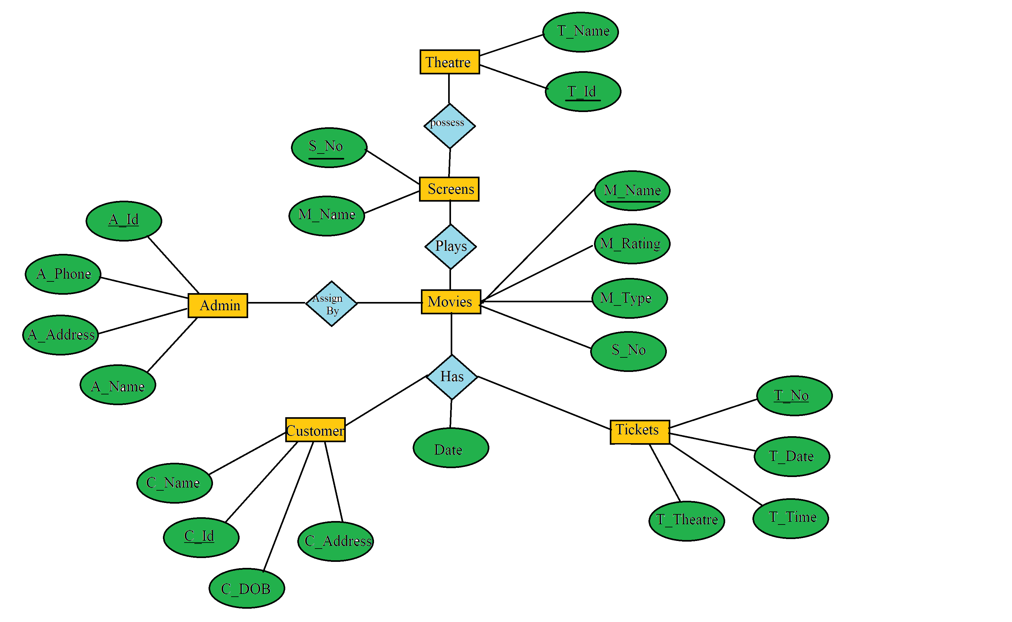

**Use Case Diagram**

To explain the better view and functionalities of the system, use case diagrams are chosen. The use case diagram is important to document the requirement of the system as well as to specify functionalities of the system. Use case diagrams better explain the way the user interacts with the system.

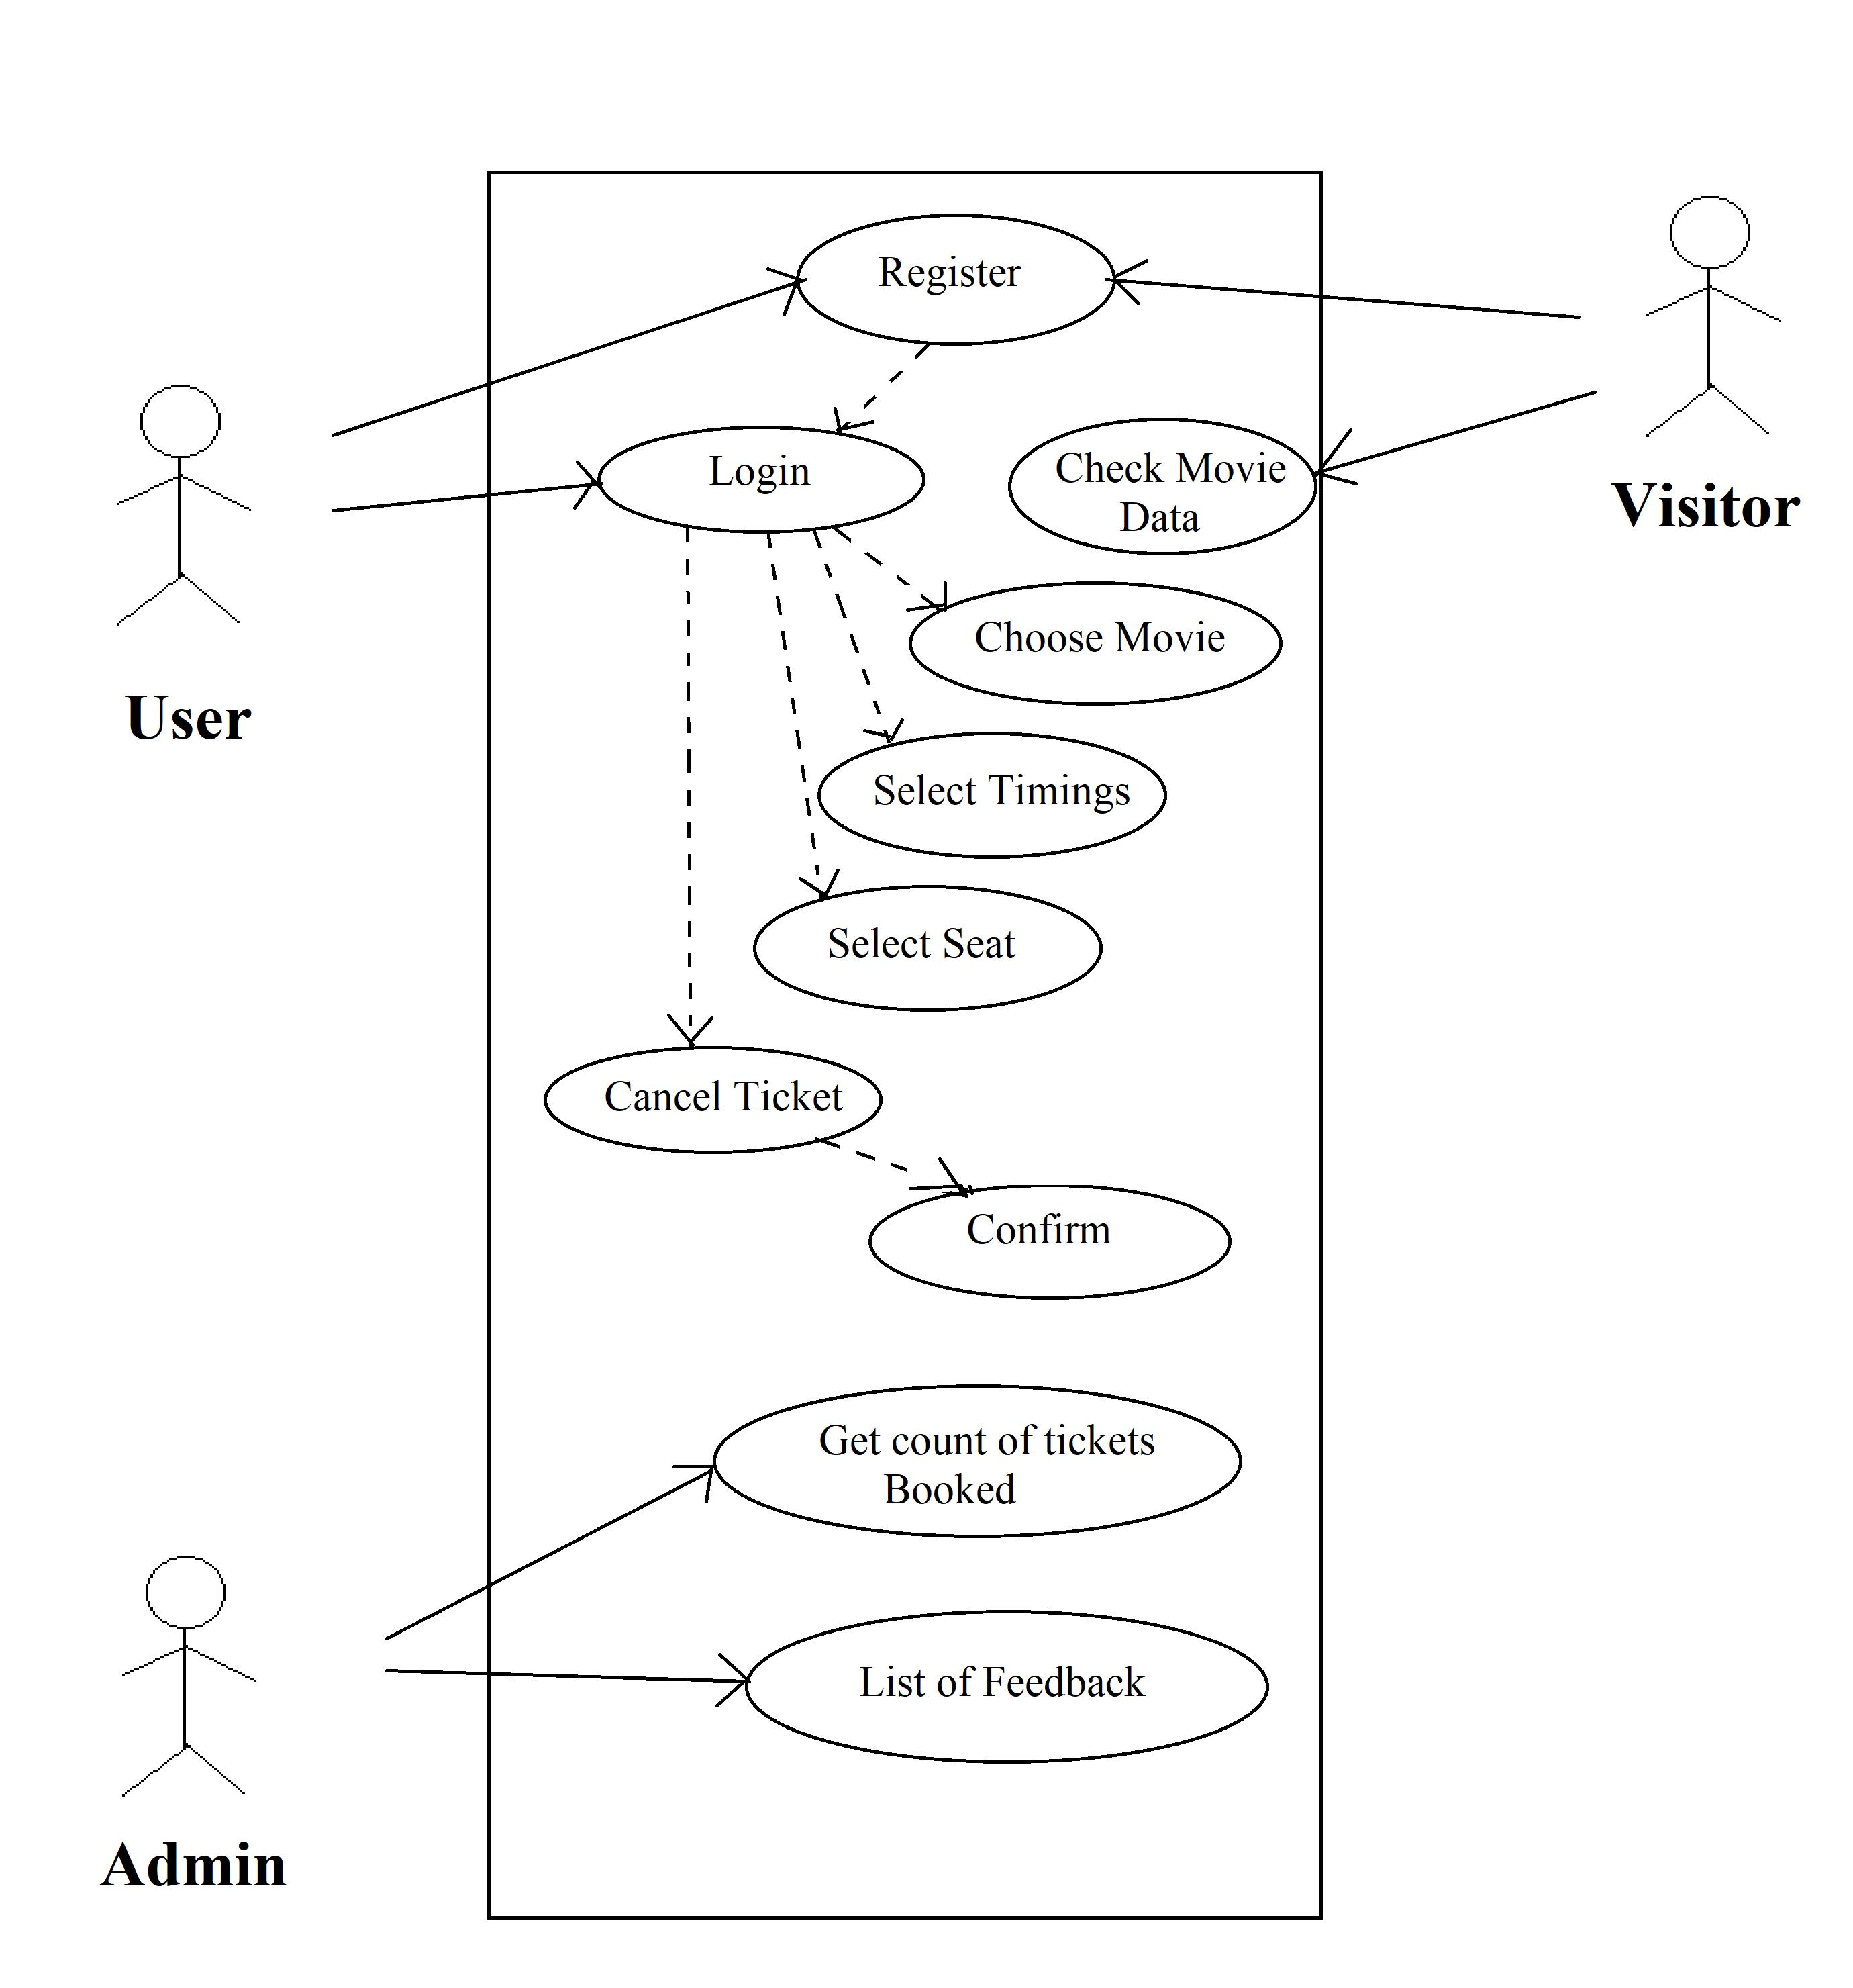

**Data Flow Diagram**

It's easy to understand the flow of data through systems with the right [data flow diagram software](https://www.lucidchart.com/pages/examples/data-flow-diagram). This guide provides everything you need to know about data flow diagrams, including definitions, history, and symbols and notations. You'll learn the different levels of a DFD, the difference between a logical and a physical DFD and tips for making a DFD.

A data flow diagram (DFD) maps out the flow of information for any process or system. It uses defined symbols like rectangles, circles and arrows, plus short text labels, to show data inputs, outputs, storage points and the routes between each destination. Data flowcharts can range from simple, even hand-drawn process overviews, to in-depth, multi-level DFDs that dig progressively deeper into how the data is handled. They can be used to analyze an existing system or model a new one. Like all the best diagrams and charts, a DFD can often visually “say” things that would be hard to explain in words, and they work for both technical and nontechnical audiences, from developer to CEO. That’s why DFDs remain so popular after all these years. While they work well for data flow software and systems, they are less applicable nowadays to visualizing interactive, real-time or database-oriented software or systems.

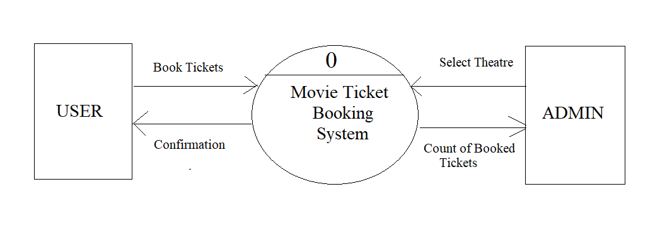

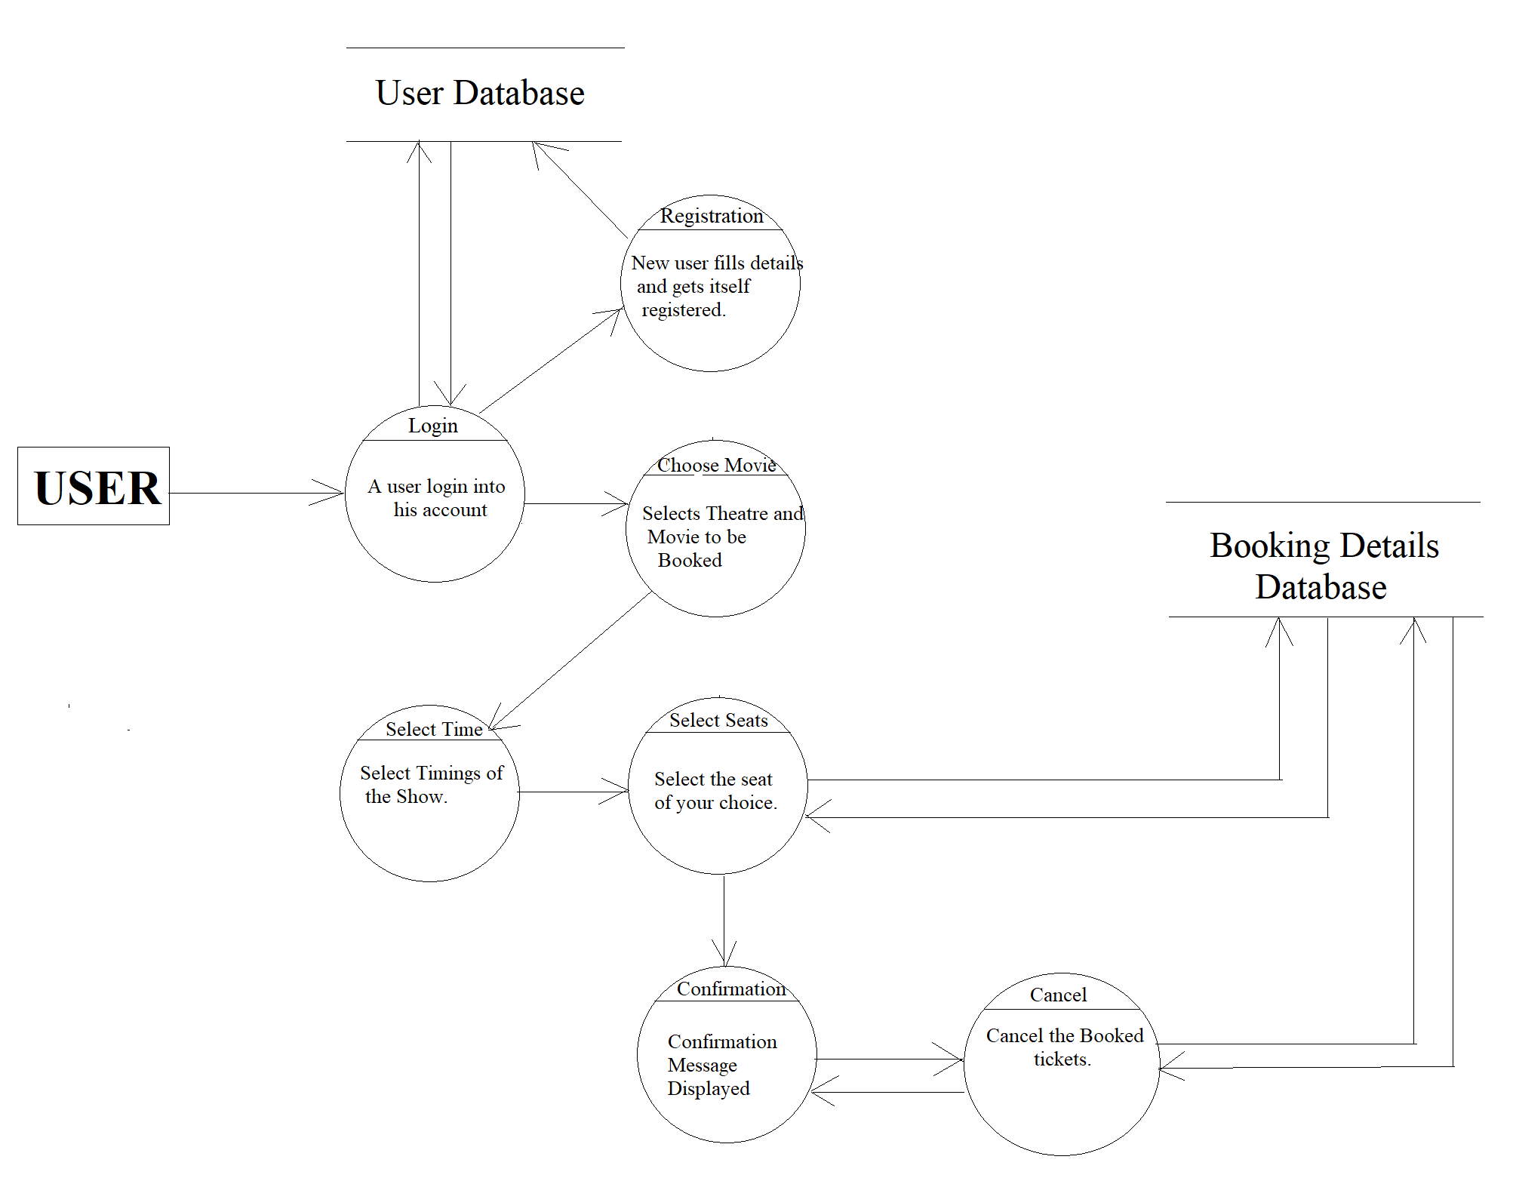

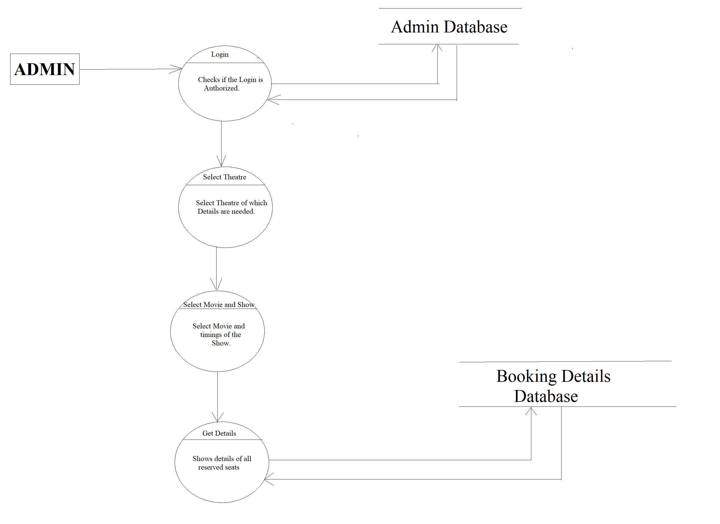

**3.4 Deployment Requirement**

Functional Requirements

* User should be able to view the list of movies which are running near to his location(based on GPS).
* User should be able to select the seat as per his choice in the hall.
* User should have different options of payment.
* The application should be able to handle 1000 ticket booking requests simultaneously.
* A customer should be able to login to the system through the first page of the application change the password after logging into the system.
* No reservation before one day can be done.
* See his/her current reservations on different movies along with the details.
* Able to choose the seats which are available for a certain class.
* Can select seats from different classes as well for same show and screen also.
* Give details about the details about the credit card.
* A message should be sent to the concerned person about the confirmation of the ticket to the specified mobile number.
* The login Id and password should be sent to the mentioned email address if a new account is created.
* The system should automatically show the fare for the corresponding shows and amount of money needs to be paid for selected seats.

Non-Functional Requirements

* The application’s servers should perform load balancing efficiently.
* Application should be lightweight and give quick response.
* The user’s data should be kept safe.
* The application should be platform independent.
* Reliability:

The capability to maintain the specified level of performance is called reliability. This application is a web based application that runs on any device that has a browser.

* Availability:

The application will be available for 99% of the time.

* Security:

The business logic is hidden from the users and is much safer and thus avoids unauthorised or illegal access or database corruption. Security of the user’s information is also safe as there is a login facility.

* Maintainability:

Maintenance is typically done after the software development has been completed. As the time evolves, so do the requirements and needs. It revolves around the understanding of the existing software and the effects of the change.

* Portability:

Portability is the ability of the system or application that can run in various environments. As the web application is based on the java language, the application is portable.

**SOFTWARE AND HARDWARE REQUIREMENTS**

* Intel core i3 7th generation is used as processor because it is faster & provide reliable and stable working environment.
* A RAM size of 8 GB is used as it will provide fast reading & writing capabilities.
* We are using Google Chrome as browser to display the HTML page as Google Chrome is vibrant, fast and clear.
* Xampp is used as an open source cross platform web server. XAMPP can also install an administration site as the home page of the server. From which you can undertake all manner of administrative tasks, such as checking the server status and security, launch tools like Php MyAdmin and Webalizer analytics.
* For coding tool; Notepad ++ is used as new programmers tend to initially learn coding in notepad so they get good hand on typing and syntaxes, etc and mainly because notepad is inbuilt and no need to install any extra application.

Chapter 4: Implementation

4.1 Software Tools

**Php**

PHP started out as a small open source project that evolved as more and more people found out how useful it was. Rasmus Lerdorf unleashed the first version of PHP way back in 1994.

* PHP is a recursive acronym for "PHP: Hypertext Preprocessor".
* PHP is a server side scripting language that is embedded in HTML. It is used to manage dynamic content, databases, session tracking, even build entire e-commerce sites.
* It is integrated with a number of popular databases, including MySQL, PostgreSQL, Oracle, Sybase, Informix, and Microsoft SQL Server.
* PHP is pleasingly zippy in its execution, especially when compiled as an Apache module on the Unix side. The MySQL server, once started, executes even very complex queries with huge result sets in record-setting time.
* PHP supports a large number of major protocols such as POP3, IMAP, and LDAP. PHP4 added support for Java and distributed object architectures (COM and CORBA), making n-tier development a possibility for the first time.
* PHP is forgiving: PHP language tries to be as forgiving as possible.
* PHP Syntax is C-Like.

## Common uses of PHP

* PHP performs system functions, i.e. from files on a system it can create, open, read, write, and close them.
* PHP can handle forms, i.e. gather data from files, save data to a file, through email you can send data, return data to the user.
* You add, delete, modify elements within your database through PHP.
* Access cookies variables and set cookies.
* Using PHP, you can restrict users to access some pages of your website.
* It can encrypt data.

## Characteristics of PHP

Five important characteristics make PHP's practical nature possible −

* Simplicity
* Efficiency
* Security
* Flexibility
* Familiarity

**Xampp**

Xampp is a [free and open source](https://en.wikipedia.org/wiki/Free_software) [cross-platform](https://en.wikipedia.org/wiki/Cross-platform) [web server](https://en.wikipedia.org/wiki/Web_server) [solution stack](https://en.wikipedia.org/wiki/Solution_stack) package developed by Apache Friends, consisting mainly of the [Apache HTTP Server](https://en.wikipedia.org/wiki/Apache_HTTP_Server), [MariaDB](https://en.wikipedia.org/wiki/MariaDB) [database](https://en.wikipedia.org/wiki/Database), and [interpreters](https://en.wikipedia.org/wiki/Interpreter_(computing)) for scripts written in the [PHP](https://en.wikipedia.org/wiki/PHP) and [Perl](https://en.wikipedia.org/wiki/Perl) [programming languages](https://en.wikipedia.org/wiki/Programming_language).

XAMPP stands for Cross-Platform (X), Apache (A), MariaDB (M), PHP (P) and Perl (P). It is a simple, lightweight Apache distribution that makes it extremely easy for developers to create a local web server for testing and deployment purposes. Everything needed to set up a web server – server application (Apache), database (MariaDB), and scripting language (PHP) – is included in an extractable file. XAMPP is also cross-platform, which means it works equally well on Linux, Mac and Windows. Since most actual web server deployments use the same components as XAMPP, it makes transitioning from a local test server to a live server extremely easy as well.

Usages:

Officially, XAMPP's designers intended it for use only as a development tool, to allow website designers and programmers to test their work on their own computers without any access to the Internet. To make this as easy as possible, many important security features are disabled by default.

XAMPP has the ability to serve web pages on the [World Wide Web](https://en.wikipedia.org/wiki/World_Wide_Web).

A special tool is provided to [password-protect](https://en.wikipedia.org/wiki/Password) the most important parts of the package.

XAMPP also provides support for creating and manipulating databases in [MariaDB](https://en.wikipedia.org/wiki/MariaDB) and [SQLite](https://en.wikipedia.org/wiki/SQLite) among others.

Once XAMPP is installed, it is possible to treat a [localhost](https://en.wikipedia.org/wiki/Localhost) like a remote host by connecting using an [FTP](https://en.wikipedia.org/wiki/File_Transfer_Protocol) client. Using a program like [FileZilla](https://en.wikipedia.org/wiki/FileZilla) has many advantages when installing a [content management system](https://en.wikipedia.org/wiki/Content_management_system) (CMS) like [Joomla](https://en.wikipedia.org/wiki/Joomla) or [WordPress](https://en.wikipedia.org/wiki/WordPress). It is also possible to connect to localhost via FTP with an [HTML editor](https://en.wikipedia.org/wiki/HTML_editor).

**MySQL**

MySQL is an Oracle-backed open source relational database management system ([RDBMS](https://searchdatamanagement.techtarget.com/definition/RDBMS-relational-database-management-system)) based on Structured Query Language ([SQL](https://searchsqlserver.techtarget.com/definition/SQL)). MySQL runs on virtually all platforms, including [Linux](https://searchdatacenter.techtarget.com/definition/Linux-operating-system), [UNIX](https://searchdatacenter.techtarget.com/definition/Unix) and [Windows](https://searchwindowsserver.techtarget.com/definition/Windows). Although it can be used in a wide range of applications, MySQL is most often associated with web applications and online publishing.

MySQL is an important component of an open source enterprise stack called [LAMP](https://whatis.techtarget.com/definition/LAMP-Linux-Apache-MySQL-PHP). LAMP is a web development platform that uses Linux as the operating system, [Apache](https://whatis.techtarget.com/definition/Apache) as the web server, MySQL as the relational database management system and [PHP](https://whatis.techtarget.com/definition/PHP-Hypertext-Preprocessor) as the object-oriented scripting language. (Sometimes [Perl](https://whatis.techtarget.com/definition/Perl) or [Python](https://whatis.techtarget.com/definition/Python) is used instead of PHP.)

Originally conceived by the Swedish company MySQL AB, MySQL was acquired by Sun Microsystems in 2008 and then by Oracle when it bought Sun in 2010. Developers can use MySQL under the GNU General Public License ([GPL](https://searchdatacenter.techtarget.com/definition/GNU-General-Public-License-GNU-GPL-or-simply-GPL)), but enterprises must obtain a commercial license from Oracle.

Today, MySQL is the RDBMS behind many of the top websites in the world and countless corporate and consumer-facing web-based applications, including Facebook, Twitter and YouTube.

### How MySQL works

MySQL is based on a [client-server](https://searchnetworking.techtarget.com/definition/client-server) model. The core of MySQL is MySQL server, which handles all of the database instructions (or commands). MySQL server is available as a separate program for use in a client-server networked environment and as a library that can be embedded (or linked) into seperate applications.

MySQL operates along with several utility programs which support the administration of MySQL databases. Commands are sent to MySQLServer via the MySQL client, which is installed on a computer.

**Apache**

Apache is the most widely used web server software. Developed and maintained by Apache Software Foundation, Apache is an open source software available for free. It runs on 67% of all webservers in the world. It is fast, reliable, and secure. It can be highly customized to meet the needs of many different environments by using extensions and modules. Most WordPress hosting providers use Apache as their web server software. However, WordPress can run on other web server software as well.

**Notepad ++**

**Notepad++** is a [text editor](https://en.wikipedia.org/wiki/Text_editor) and [source code editor](https://en.wikipedia.org/wiki/Source_code_editor) for use with [Microsoft Windows](https://en.wikipedia.org/wiki/Microsoft_Windows). It supports [tabbed](https://en.wikipedia.org/wiki/Tab_(GUI)) editing, which allows working with multiple open files in a single window. The project's name comes from the [C](https://en.wikipedia.org/wiki/C_(programming_language)) [increment operator](https://en.wikipedia.org/wiki/Increment_operator).

Notepad++ is distributed as [free software](https://en.wikipedia.org/wiki/Free_software). At first the project was hosted on [SourceForge.net](https://en.wikipedia.org/wiki/SourceForge.net), from where it has been downloaded over 28 million times, and twice won the SourceForge Community Choice Award for Best Developer Tool. The project was hosted on [TuxFamily](https://en.wikipedia.org/w/index.php?title=TuxFamily&action=edit&redlink=1)  from 2010 to 2015; since 2015 Notepad++ has been hosted on [GitHub](https://en.wikipedia.org/wiki/GitHub). Notepad++ uses the [Scintilla editor component](https://en.wikipedia.org/wiki/Scintilla_(software)).

4.2 Screenshots

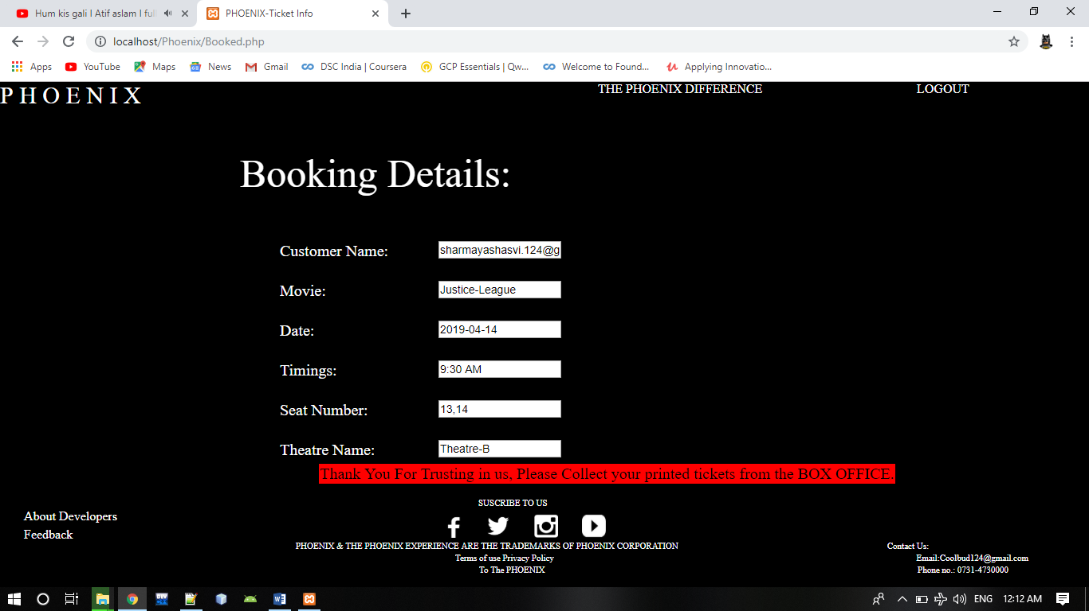

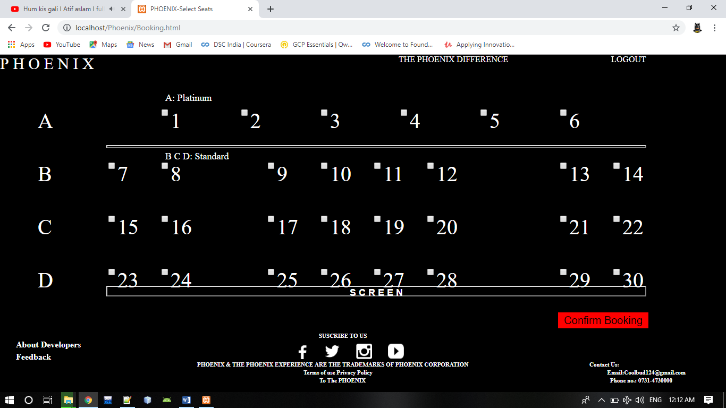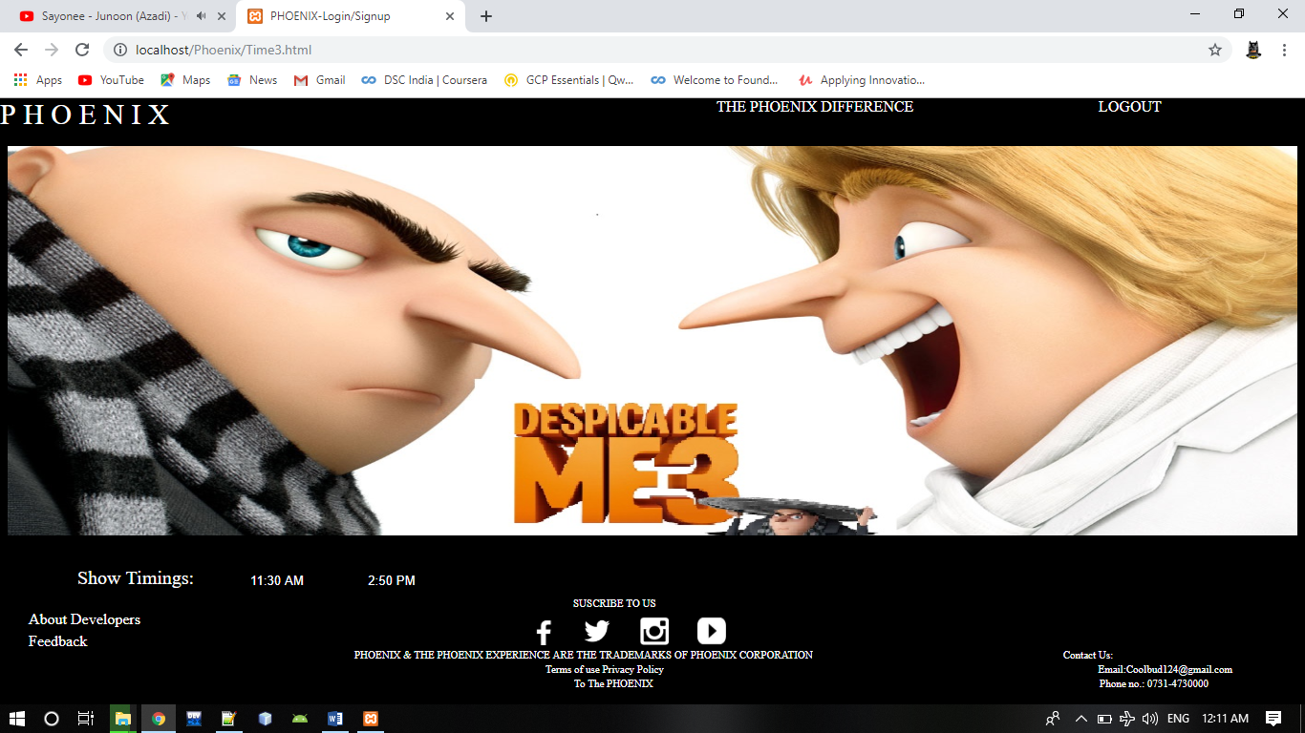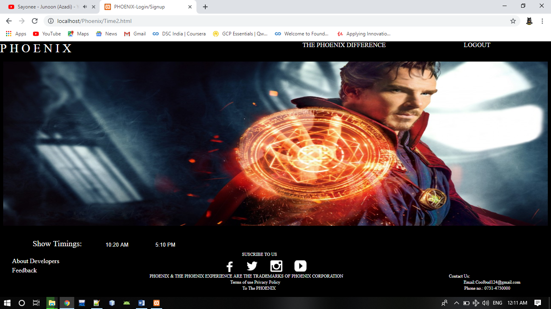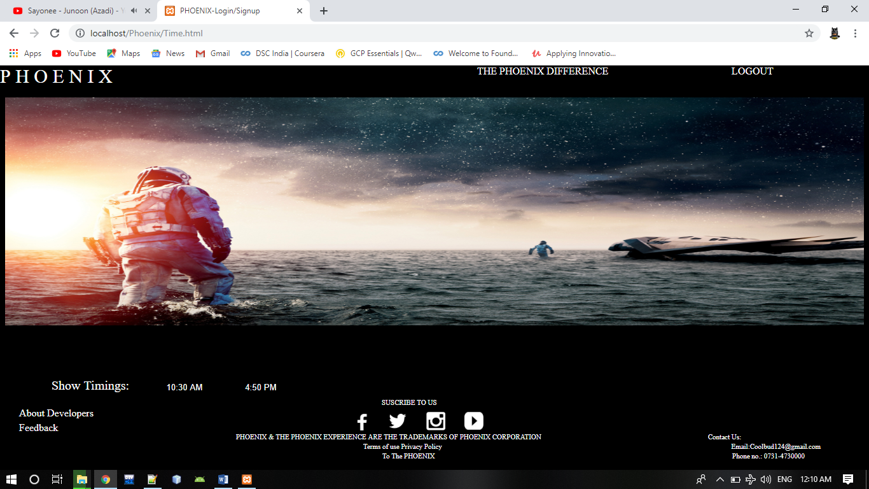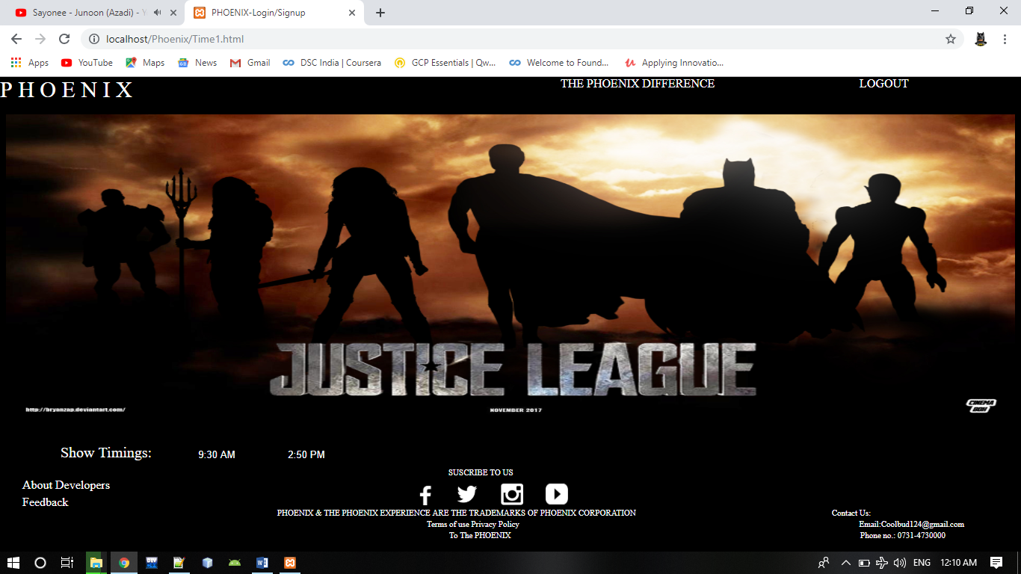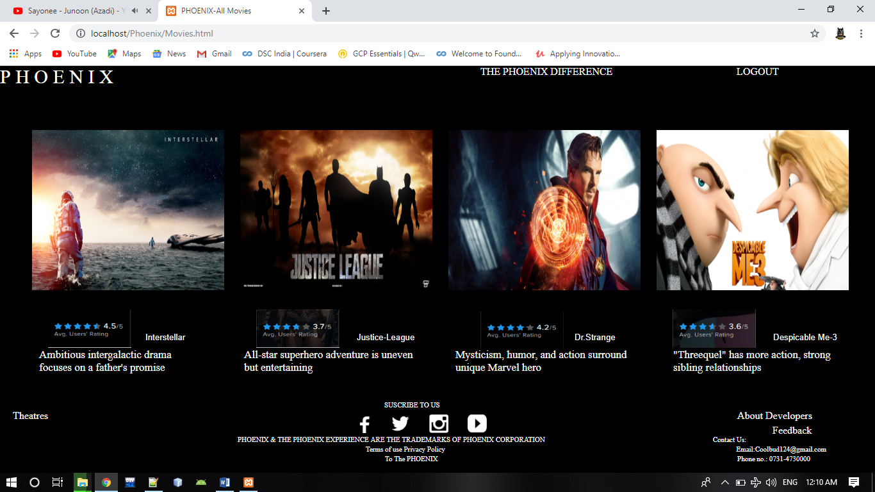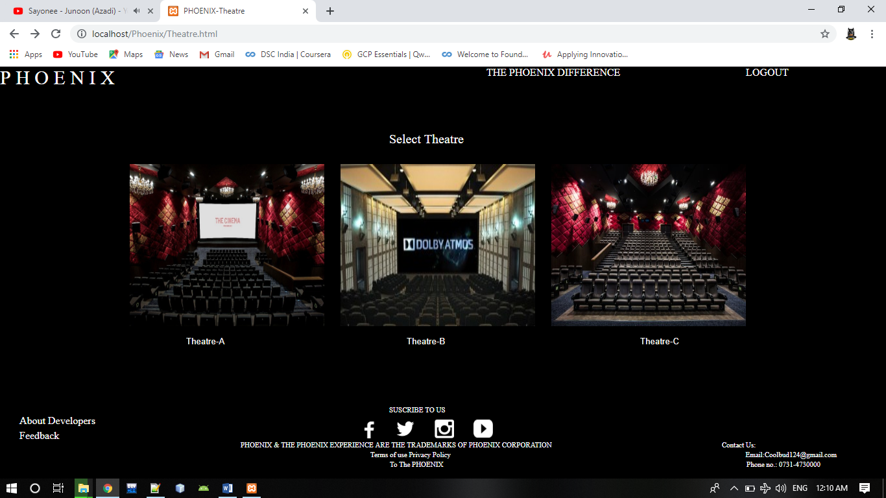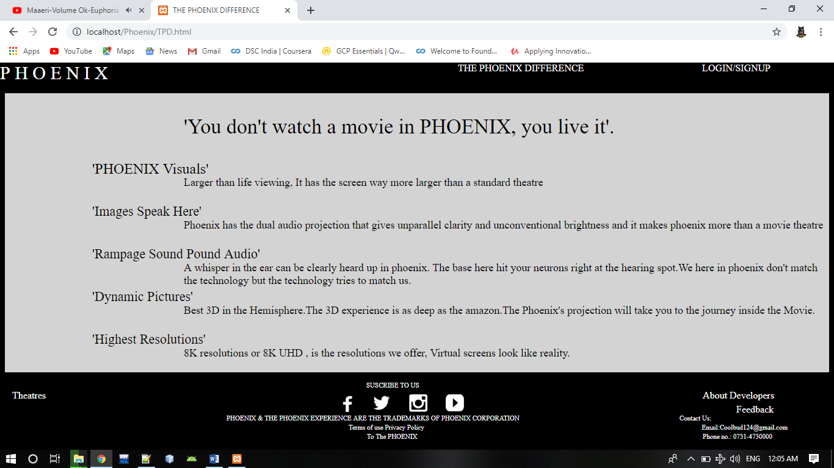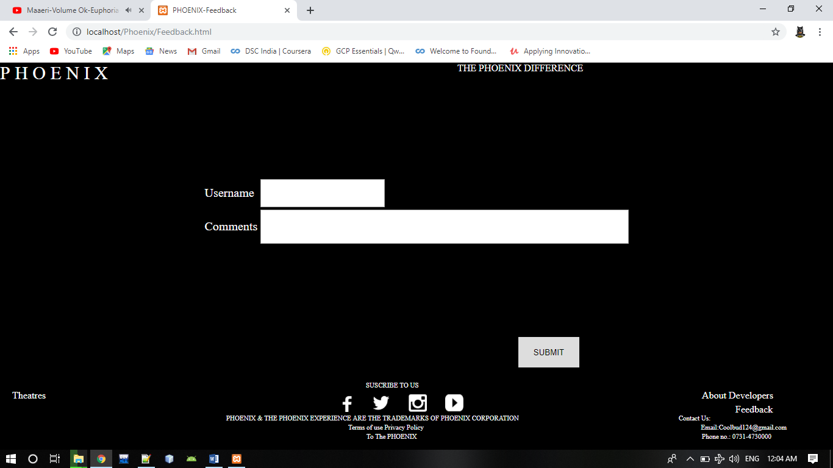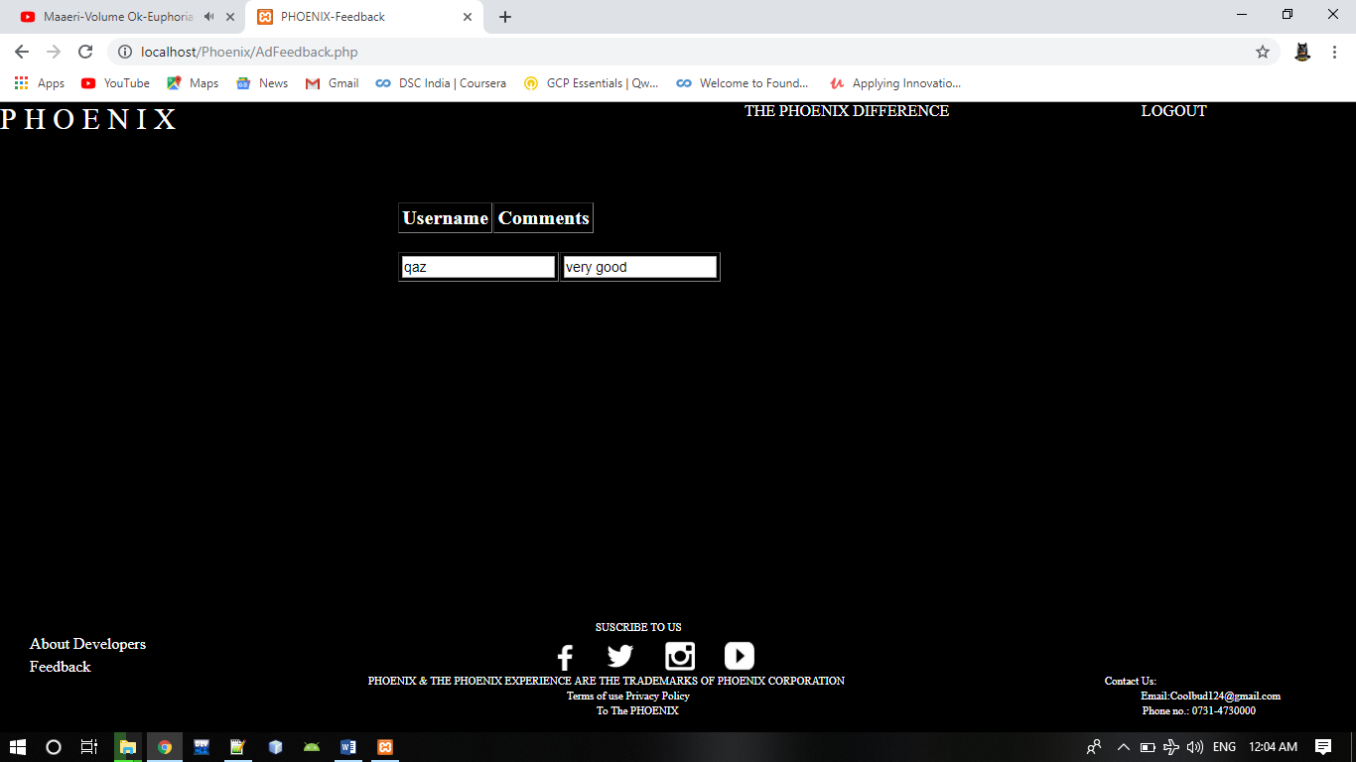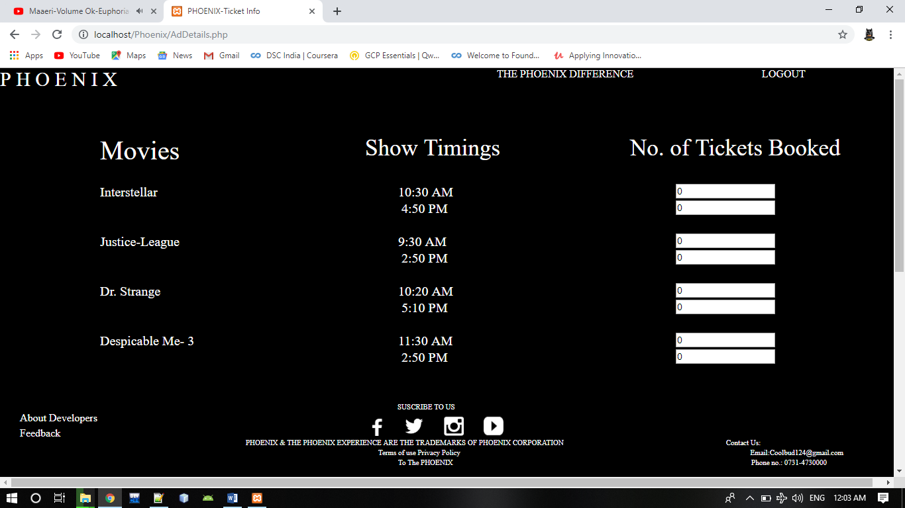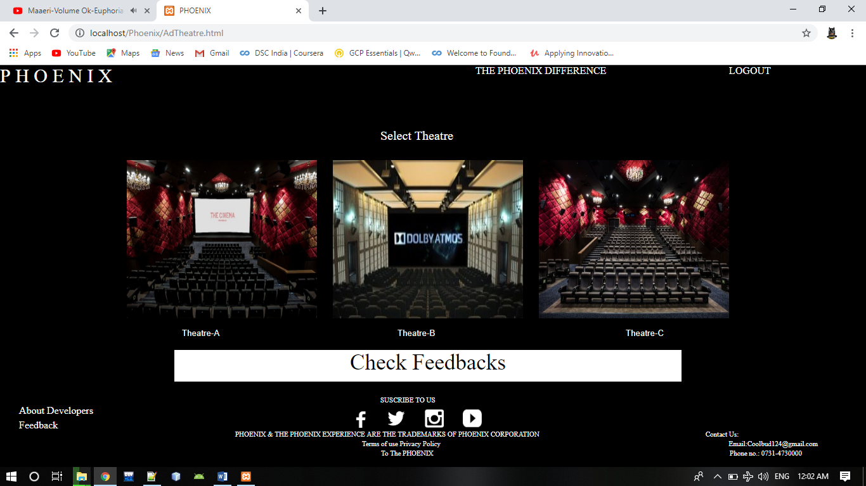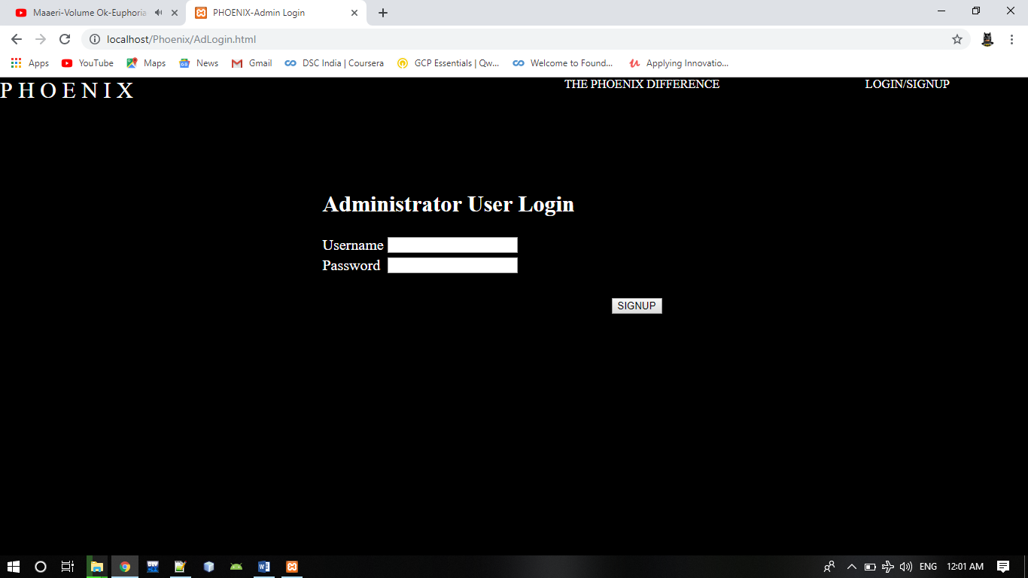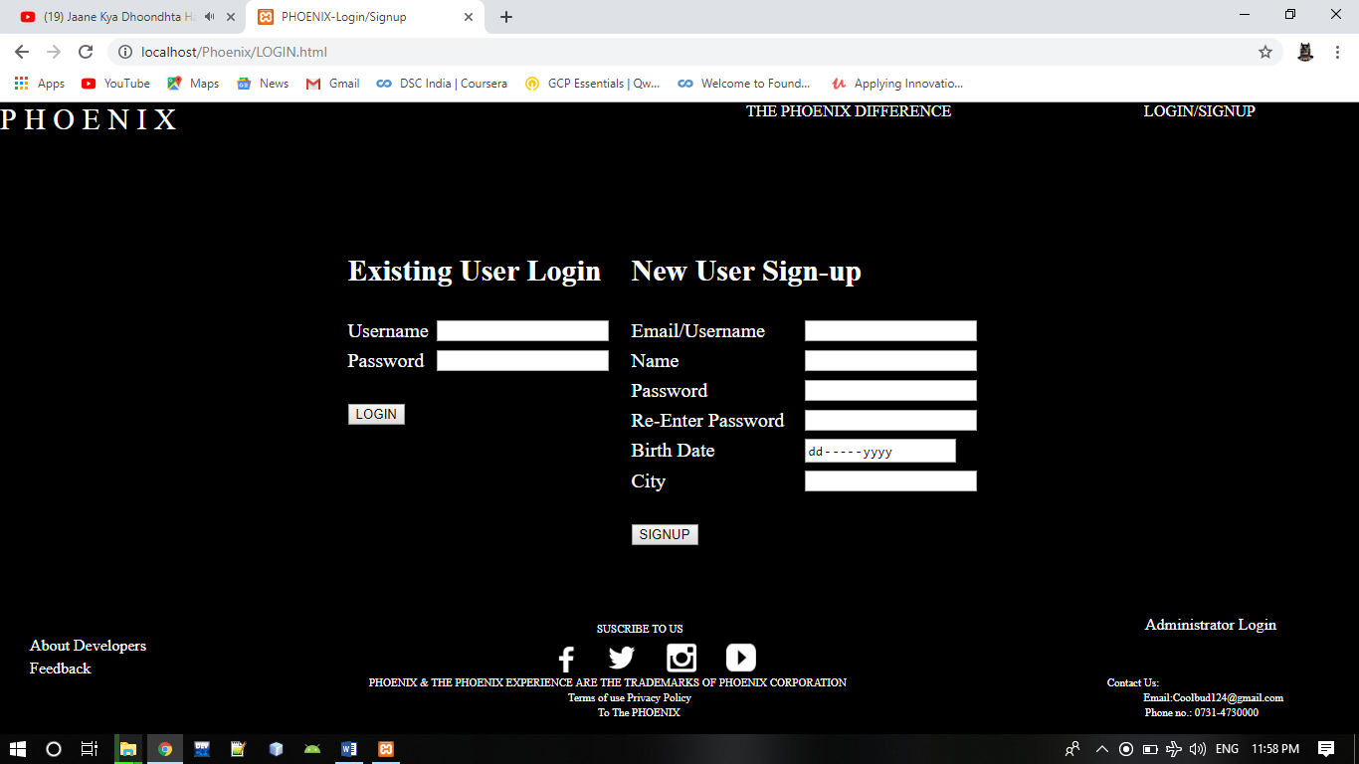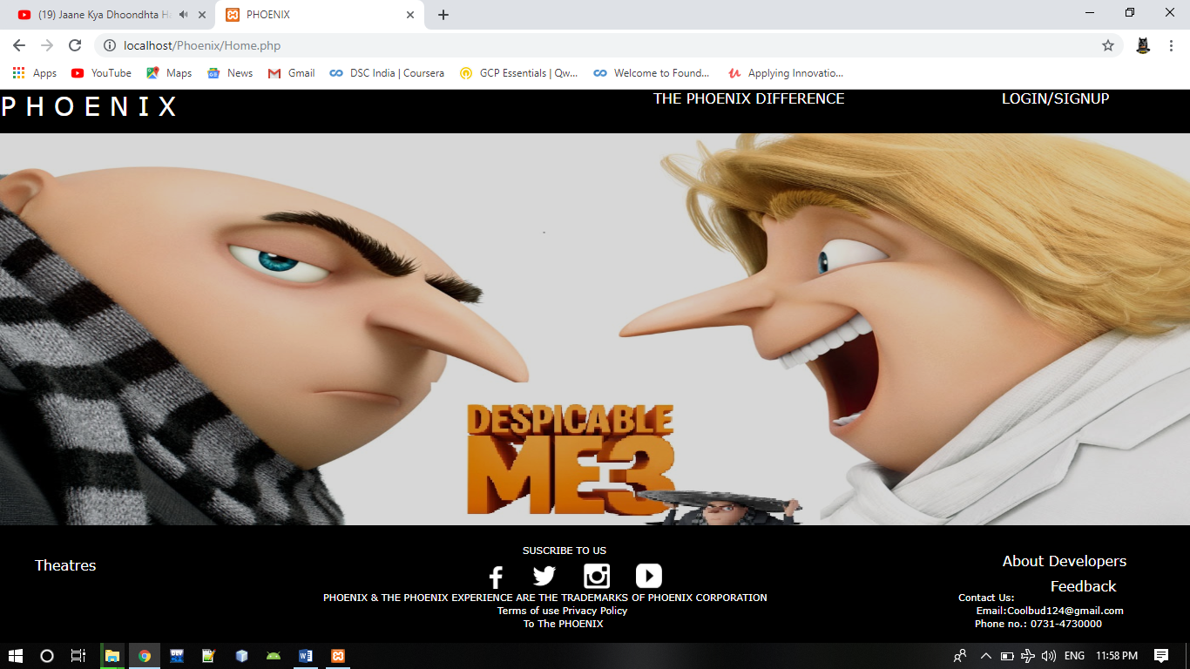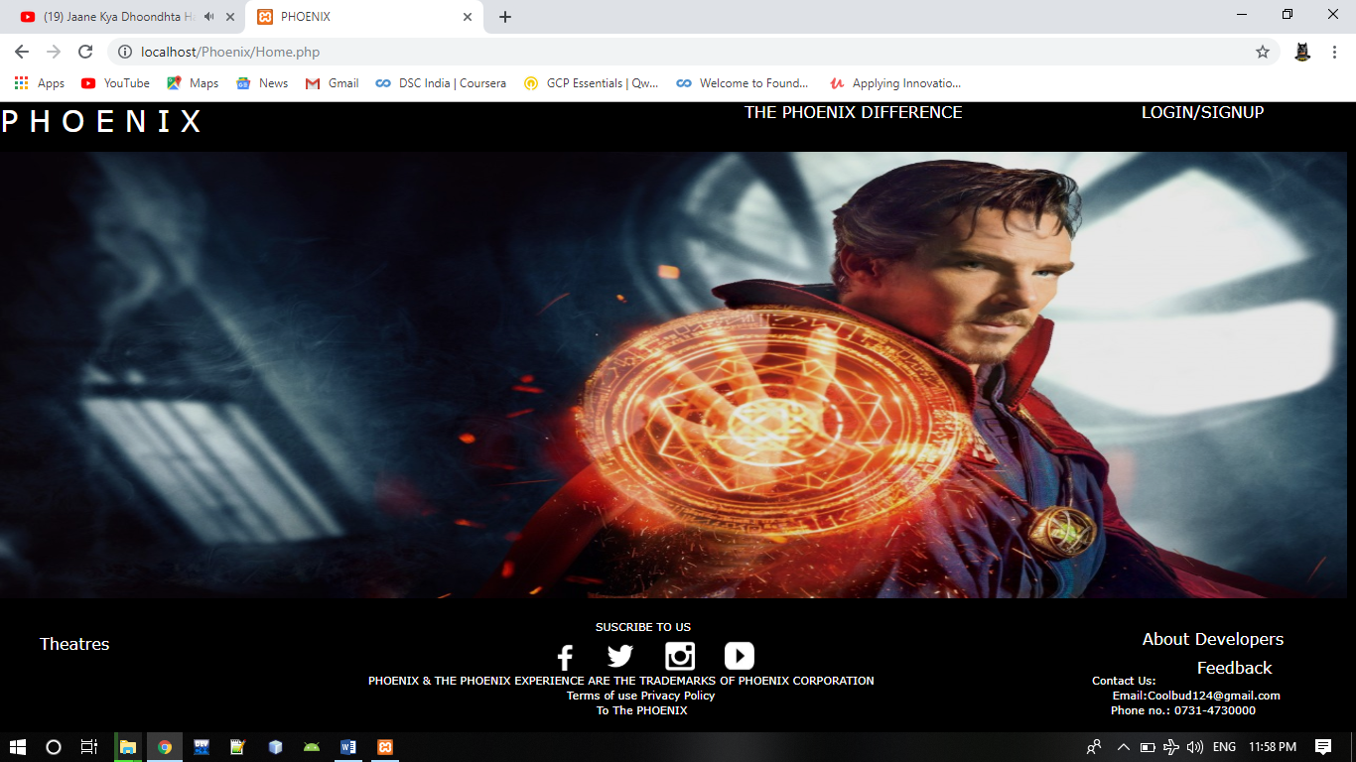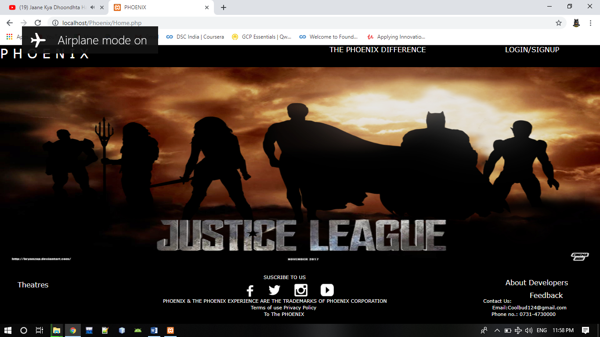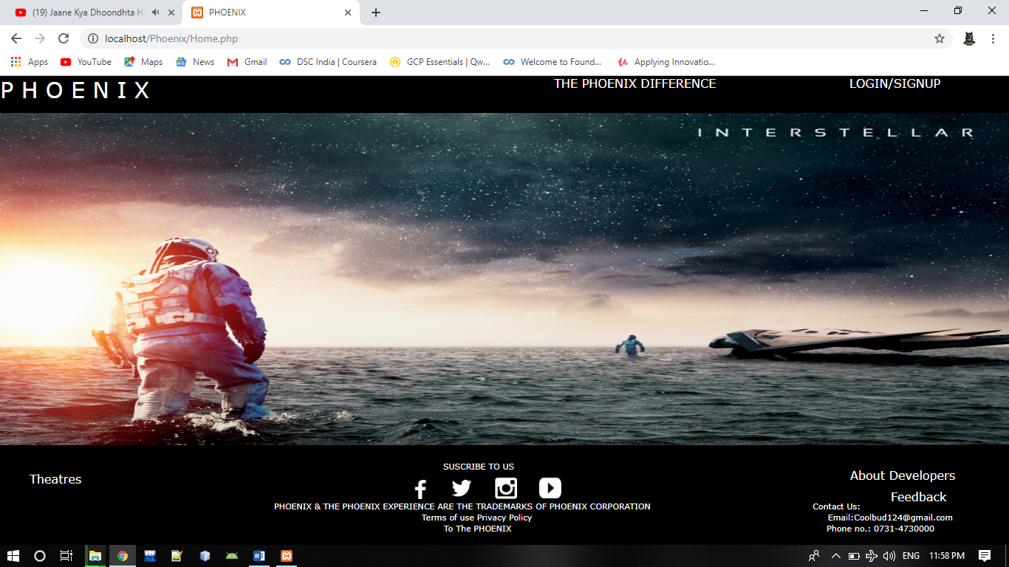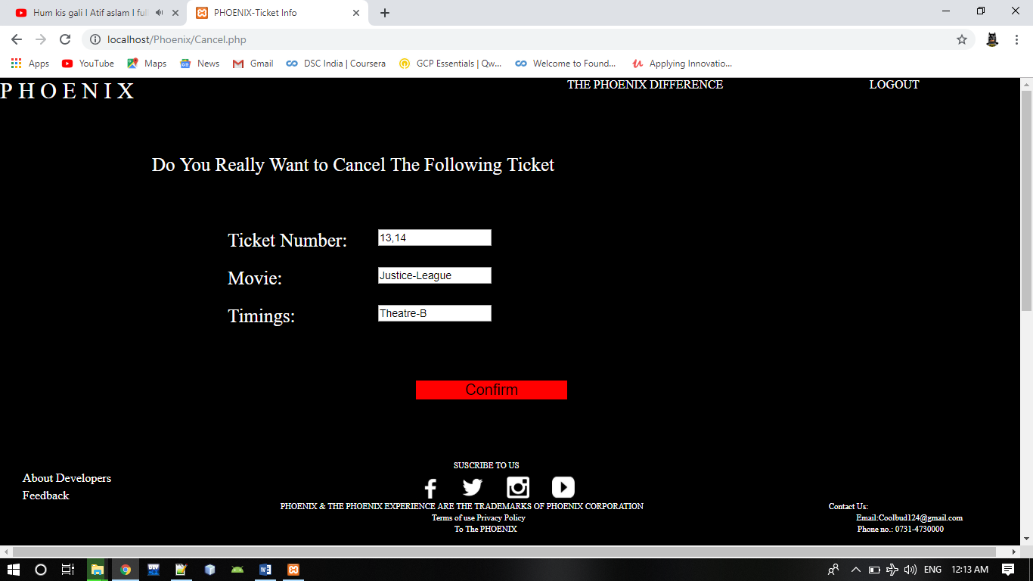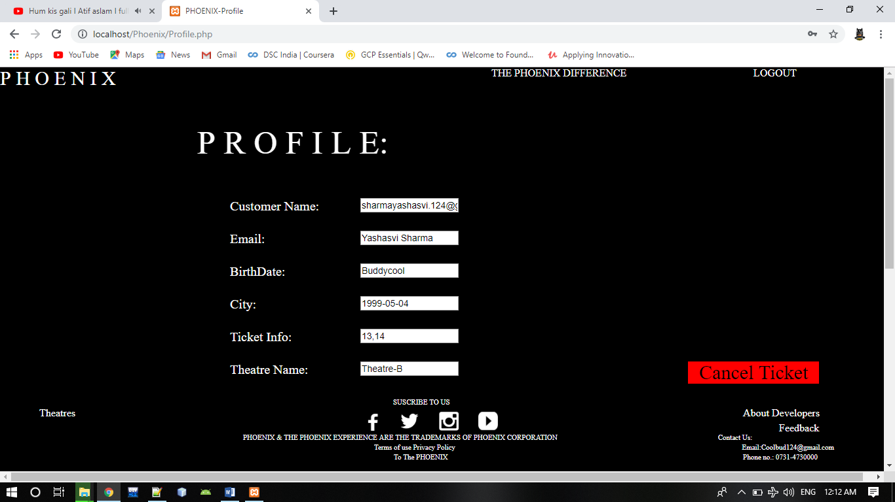

**4.3 Test Case Design**

Testing can be done either manually or automation testing. Automation testing finally leads to regression testing. Manual testing leads to unit testing. To check for business requirements, we have used unit testing that will be performed on the entire function system, i.e. for each and every function of the calculator. This testing tests each and every function with regards to its output as expected by the user.

Test Cases

Login Page

|  |  |  |  |  |
| --- | --- | --- | --- | --- |
| Sr. No | Test ID | Objective | Description | Expected Result |
| 1 | TC001 | To check textures whether it accept char and numeric both | Type both char  And numeric  In text users | Should Accept |
| 2 | TC002 | Text user should maximum 10 characters | Type 10 char In text user | Give Error Message |
| 3 | TC003 | Text password  Should not display  Asterisk | Type in the  Text password | Only asterisk |

|  |  |  |  |  |
| --- | --- | --- | --- | --- |
| 4 | TC004 | To check the functionality of  Login button | Type valid username and  Password | Redirect to home page |
| 5 | TC005 | To check the | Type either | Error |
|  |  | working of | invalid | message |
|  |  | login button | username or |  |
|  |  |  | invalid |  |
|  |  |  | password |  |

New Customer Registration Page

|  |  |  |  |  |
| --- | --- | --- | --- | --- |
| Sr. No | Test id | Objective | Description | Expected Result |
| 1 | Tc_1 | To check the length of login name field | Type in login field | Accept |
| 2 | Tc_2 | To check the functionality of Registration | Type the existing name in text name | Accept |
| 3 | Tc_3 | To check the functionality of Email Id | Type invalid email id in this field | Error message |

Chapter 5: Conclusion

Nowadays, traditional reservation ways of cinema ticketing is dying. It’s new age where technology dominates human life. With the software and technological devices, exceptions are reduced and even terminated. Also, people prefer easy, quick and safe way for every part of his life. This project is designed to meet the requirements of a cinema ticket booking system. It has been developed in PHP and the database has been built in My SQL server keeping in mind the specifications of the system.

In our project: with this cinema ticketing system; cinema companies can satisfy comfortable facilities to their customers. The relationship between cinema manager, employee, and customer satisfy a good communication to complete ticketing process. With this platform we developed, we are hoping to reduce time wasting, avoid misunderstandings, provide easy data flow, customer pleasure, and less hard work. We believe that we have accomplished our goals and satisfied with the code we developed.

Bibliography

[1] Elmasri and Navathe, “Fundamentals of Database Systems” , 3/e, Addison - Wesley, 2001

[2] A Silberschaltz, H.F. Korth, and S sudarshan, “Database System Concepts”, 3/e, Tata Mcgraw Hill,1997

[3] Thomas M. Connolly, Carolyn E. Begg, “Database Systems & Practical Approach to Design Implementation and Management”, 4/e, Addison – Wesley, 2005

[4] [www.W3Schools.com](http://www.W3Schools.com)

[5] [www.stackoverflow.com](http://www.stackoverflow.com)

[6] [www.ajaykhatri.in](http://www.ajaykhatri.in)

[7] <https://www.tutorialspoint.com/php/index.htm>l

Guide Interaction Sheet

|  |  |  |
| --- | --- | --- |
| **Week** | **Date** | **Remarks** |
| 1 | 12/03/19 | UML Diagrams |
| 2 | 27/03/19 | User & Admin Panel |
| 3 | 05/04/19 | Project Demo |

Source Code

**Theatre.html**

<!Doctype HTML>

<html>

<head>

<title>PHOENIX-Theatre</title>

</head>

<body bgcolor="#000000">

<form action="Home.php" method="GET" id="form1">

</form>

<a href="Home.php" style="text-decoration:none; height:50px;width:750px;position:absolute;left:0px;top:0px;background-color:none;text-align:left;

font-size:30px;

background-color: #000000;

border: none;

color: white;

font:Courier New">P H O E N I X</a>

<a href="TPD.html" style="text-decoration:none; background-color: #000000; height:50px;width:400px;position:absolute; left:750px; top:0px; background-color:none;color: white;

font:Courier New">THE PHOENIX DIFFERENCE</a>

<a href="Home.php" style="text-decoration:none; background-color: #000000; height:50px;width:215px;position:absolute; left:1150px; top:0px; background-color:none;color: white;

font:Courier New">LOGOUT</a>

<form method="GET" id="form2" action="Theatre.php" style="top:100px">

<table>

<caption style="position:absolute; left:600px; top:100px;font-size:20px;"><font color="white">Select Theatre</caption>

<img name="T_Name" value="Theatre-A" border="0" src="Th1.jpg" width="300" height="250" style="position:absolute;left:200px;Top:150px;">

<td style="position:absolute; left:280px; top:400px; font-size:30px;">

<input name="Th" type="Submit" value="Theatre-A" style=" background-color:black; color:White; border:0px"></B>Theatre A</input></td>

<img name="T_Name" value="Theatre-B" border="0" src="Th2.jpg" width="300" height="250"style="position:absolute;left:525px;Top:150px;">

<td style="position:absolute; left:620px; top:400px; font-size:30px;">

<input name="Th" type="Submit" value="Theatre-B" style=" background-color:black; color:White; border:0px"></B>Theatre B</input></td>

<img name="T_Name" value="Theatre-C" border="0" src="Th3.jpg" width="300" height="250"style="position:absolute;left:850px;Top:150px;">

<td style="position:absolute;left:980px; top:400px; font-size:30px;">

<input name="Th" type="Submit" value="Theatre-C" style=" background-color:black; color:White; border:0px"></B>Theatre C</input></td>

</table>

</form>

<table>

<caption style="position:absolute; left:600px; bottom:100px;font-size:11px;"><font color="white">SUSCRIBE TO US</caption>

<tr>

<a href="https://www.facebook.com"><img src = "facebook.png"width = "30" height = "30" style="position:absolute;left:550px;Bottom:62px;"></a>

<a href="https://twitter.com"><img src = "twitter.png"width = "30" height = "30" style="position:absolute;left:610px;Bottom:62px;"></a>

<a href="https://www.instagram.com/accounts/login"><img src = "instagram.png"width = "30" height = "30" style="position:absolute;left:670px;

Bottom:62px;"></a>

<a href="https://www.youtube.com"><img src = "youtube.jfif"width = "30" height = "30" style="position:absolute;left:730px;Bottom:62px;"></a>

<td style="position:absolute; left:370px; bottom:45px;font-size:11px;"><font color="white">PHOENIX & THE PHOENIX EXPERIENCE ARE THE

TRADEMARKS OF PHOENIX CORPORATION</td>

<td style="position:absolute; right:200px; bottom:45px;font-size:11px;"><font color="white">Contact Us:</td>

<td style="position:absolute; left:570px; bottom:30px;font-size:11px;"><font color="white"> Terms of use Privacy Policy </td>

<td style="position:absolute; right:75px; bottom:30px;font-size:11px;"><font color="white"> Email:Coolbud124@gmail.com </td>

<td style="position:absolute; left:600px; bottom:15px;font-size:11px;"><font color="white"> To The PHOENIX </td>

<td style="position:absolute; right:100px; bottom:15px;font-size:11px;"><font color="white"> Phone no.: 0731-4730000</td>

<a href="About.html" style="text-decoration:none; height:font:Courier New;width:200px;position:absolute; left:30px; bottom:80px; background-color:black; color:white;">About Developers</a>

<a href="Feedback.html" style="text-decoration:none; height:20px;width:150px;font:Courier New;position:absolute; left:30px; bottom:55px; background-color:black; color:white;">Feedback</a>

</tr>

</table>

Time.html

<!Doctype HTML>

<html>

<head>

<title>PHOENIX-Login/Signup</title>

</head>

<body bgcolor="#000000">

<form action="Home.php" method="GET" id="form1">

</form>

<a href="Home.php" style="text-decoration:none; height:50px;width:750px;position:absolute;left:0px;top:0px;background-color:none;text-align:left;

font-size:30px;

background-color: #000000;

border: none;

color: white;

font:Courier New">P H O E N I X</a>

<a href="TPD.html" style="text-decoration:none; background-color: #000000; height:50px;width:400px;position:absolute; left:750px; top:0px; background-color:none;color: white;

font:Courier New">THE PHOENIX DIFFERENCE</a>

<a href="Home.php" style="text-decoration:none; background-color: #000000; height:50px;width:215px;position:absolute; left:1150px; top:0px; background-color:none;color: white;

font:Courier New">LOGOUT</a>

<form method="GET" id="form2" action="Time.php" style="top:100px">

<table>

<tr>

<img src="1.jpeg" style="width:100%;height:400px;top:100px;bottom:150px;">

<td style="position:absolute; left:80px; bottom:120px;font-size:20px;"><font color="white">Show Timings:</td>

<td><input name="Time" type="Submit" value="10:30 AM" style="text-decoration:none;font:Courier;height:20px;width:80px;position:absolute; left:250px;

bottom:120px; background-color:black; color:white;border:0px">10:30 AM</input></td>

<td><input name="Time" type="Submit" value="4:50 PM" style="text-decoration:none;font:Courier;height:20px;width:80px;position:absolute; left:370px;

bottom:120px; background-color:black; color:white;border:0px">4:50 PM</input></td>

</tr>

</table>

</form>

<table>

<caption style="position:absolute; left:600px; bottom:100px;font-size:11px;"><font color="white">SUSCRIBE TO US</caption>

<tr>

<a href="https://www.facebook.com"><img src = "facebook.png"width = "30" height = "30" style="position:absolute;left:550px;Bottom:62px;"></a>

<a href="https://twitter.com"><img src = "twitter.png"width = "30" height = "30" style="position:absolute;left:610px;Bottom:62px;"></a>

<a href="https://www.instagram.com/accounts/login"><img src = "instagram.png"width = "30" height = "30" style="position:absolute;left:670px;

Bottom:62px;"></a>

<a href="https://www.youtube.com"><img src = "youtube.jfif"width = "30" height = "30" style="position:absolute;left:730px;Bottom:62px;"></a>

<td style="position:absolute; left:370px; bottom:45px;font-size:11px;"><font color="white">PHOENIX & THE PHOENIX EXPERIENCE ARE THE

TRADEMARKS OF PHOENIX CORPORATION</td>

<td style="position:absolute; right:200px; bottom:45px;font-size:11px;"><font color="white">Contact Us:</td>

<td style="position:absolute; left:570px; bottom:30px;font-size:11px;"><font color="white"> Terms of use Privacy Policy </td>

<td style="position:absolute; right:75px; bottom:30px;font-size:11px;"><font color="white"> Email:Coolbud124@gmail.com </td>

<td style="position:absolute; left:600px; bottom:15px;font-size:11px;"><font color="white"> To The PHOENIX </td>

<td style="position:absolute; right:100px; bottom:15px;font-size:11px;"><font color="white"> Phone no.: 0731-4730000</td>

<a href="About.html" style="text-decoration:none; height:font:Courier New;width:200px;position:absolute; left:30px; bottom:80px; background-color:black; color:white;">About Developers</a>

<a href="Feedback.html" style="text-decoration:none; height:20px;width:150px;font:Courier New;position:absolute; left:30px; bottom:55px; background-color:black; color:white;">Feedback</a>

</tr>

</table>

Time1.html

<!Doctype HTML>

<html>

<head>

<title>PHOENIX-Login/Signup</title>

<style>

.button:hover{

border: 1px solid #888;

background-color: #000000;

color:white;

</style>

</head>

<body bgcolor="#000000">

<form action="Home.php" method="GET" id="form1">

</form>

<a href="Home.php" style="text-decoration:none; height:50px;width:750px;position:absolute;left:0px;top:0px;background-color:none;text-align:left;

font-size:30px;

background-color: #000000;

border: none;

color: white;

font:Courier New">P H O E N I X</a>

<a href="TPD.html" style="text-decoration:none; background-color: #000000; height:50px;width:400px;position:absolute; left:750px; top:0px; background-color:none;color: white;

font:Courier New">THE PHOENIX DIFFERENCE</a>

<a href="Home.php" style="text-decoration:none; background-color: #000000; height:50px;width:215px;position:absolute; left:1150px; top:0px; background-color:none;color: white;

font:Courier New">LOGOUT</a>

<form method="GET" action="Time1.php" id="form2">

<table>

<tr>

<img src="2.jpeg" style="width:100%;height:450px;top:100px;bottom:150px;">

<td style="position:absolute; left:80px; bottom:120px;font-size:20px;"><font color="white">Show Timings:</td>

<td><input name="Time" type="Submit" value="9:30 AM" style="text-decoration:none;font:Courier;height:20px;width:80px;position:absolute; left:250px;

bottom:120px; background-color:black; color:white;border:0px">9:30 AM</input></td>

<td><input name="Time" type="Submit" value="2:50 PM" style="text-decoration:none;font:Courier;height:20px;width:80px;position:absolute; left:370px;

bottom:120px; background-color:black; color:white;border:0px">2:50 PM</input></td>

</tr>

</table>

</form>

<table>

<caption style="position:absolute; left:600px; bottom:100px;font-size:11px;"><font color="white">SUSCRIBE TO US</caption>

<tr>

<a href="https://www.facebook.com"><img src = "facebook.png"width = "30" height = "30" style="position:absolute;left:550px;Bottom:62px;"></a>

<a href="https://twitter.com"><img src = "twitter.png"width = "30" height = "30" style="position:absolute;left:610px;Bottom:62px;"></a>

<a href="https://www.instagram.com/accounts/login"><img src = "instagram.png"width = "30" height = "30" style="position:absolute;left:670px;

Bottom:62px;"></a>

<a href="https://www.youtube.com"><img src = "youtube.jfif"width = "30" height = "30" style="position:absolute;left:730px;Bottom:62px;"></a>

<td style="position:absolute; left:370px; bottom:45px;font-size:11px;"><font color="white">PHOENIX & THE PHOENIX EXPERIENCE ARE THE

TRADEMARKS OF PHOENIX CORPORATION</td>

<td style="position:absolute; right:200px; bottom:45px;font-size:11px;"><font color="white">Contact Us:</td>

<td style="position:absolute; left:570px; bottom:30px;font-size:11px;"><font color="white"> Terms of use Privacy Policy </td>

<td style="position:absolute; right:75px; bottom:30px;font-size:11px;"><font color="white"> Email:Coolbud124@gmail.com </td>

<td style="position:absolute; left:600px; bottom:15px;font-size:11px;"><font color="white"> To The PHOENIX </td>

<td style="position:absolute; right:100px; bottom:15px;font-size:11px;"><font color="white"> Phone no.: 0731-4730000</td>

<a href="About.html" style="text-decoration:none; height:font:Courier New;width:200px;position:absolute; left:30px; bottom:80px; background-color:black; color:white;">About Developers</a>

<a href="Feedback.html" style="text-decoration:none; height:20px;width:150px;font:Courier New;position:absolute; left:30px; bottom:55px; background-color:black; color:white;">Feedback</a>

</tr>

</table>

Time2.html

<!Doctype HTML>

<html>

<head>

<title>PHOENIX-Login/Signup</title>

<style>

.button:hover{

border: 1px solid #888;

background-color: #000000;

color:white;

</style>

</head>

<body bgcolor="#000000">

<form action="Home.php" method="GET" id="form1">

</form>

<a href="Home.php" style="text-decoration:none; height:50px;width:750px;position:absolute;left:0px;top:0px;background-color:none;text-align:left;

font-size:30px;

background-color: #000000;

border: none;

color: white;

font:Courier New">P H O E N I X</a>

<a href="TPD.html" style="text-decoration:none; background-color: #000000; height:50px;width:400px;position:absolute; left:750px; top:0px; background-color:none;color: white;

font:Courier New">THE PHOENIX DIFFERENCE</a>

<a href="Home.php" style="text-decoration:none; background-color: #000000; height:50px;width:215px;position:absolute; left:1150px; top:0px; background-color:none;color: white;

font:Courier New">LOGOUT</a>

<form method="GET" id="form2" action="Time2.php">

<table>

<tr>

<img src="3.jpeg" style="width:100%;height:450px;top:100px;bottom:150px;">

<td style="position:absolute; left:80px; bottom:120px;font-size:20px;"><font color="white">Show Timings:</td>

<td><input name="Time" type="Submit" value="10:20 AM" style="text-decoration:none;font:Courier;height:20px;width:80px;position:absolute; left:250px;

bottom:120px; background-color:black; color:white;border:0px">10:20 AM</input></td>

<td><input name="Time" type="Submit" value="5:10 PM" style="text-decoration:none;font:Courier;height:20px;width:80px;position:absolute; left:370px;

bottom:120px; background-color:black; color:white;border:0px">5:10 PM</input></td>

</tr>

</table>

</form>

<table>

<caption style="position:absolute; left:600px; bottom:100px;font-size:11px;"><font color="white">SUSCRIBE TO US</caption>

<tr>

<a href="https://www.facebook.com"><img src = "facebook.png"width = "30" height = "30" style="position:absolute;left:550px;Bottom:62px;"></a>

<a href="https://twitter.com"><img src = "twitter.png"width = "30" height = "30" style="position:absolute;left:610px;Bottom:62px;"></a>

<a href="https://www.instagram.com/accounts/login"><img src = "instagram.png"width = "30" height = "30" style="position:absolute;left:670px;

Bottom:62px;"></a>

<a href="https://www.youtube.com"><img src = "youtube.jfif"width = "30" height = "30" style="position:absolute;left:730px;Bottom:62px;"></a>

<td style="position:absolute; left:370px; bottom:45px;font-size:11px;"><font color="white">PHOENIX & THE PHOENIX EXPERIENCE ARE THE

TRADEMARKS OF PHOENIX CORPORATION</td>

<td style="position:absolute; right:200px; bottom:45px;font-size:11px;"><font color="white">Contact Us:</td>

<td style="position:absolute; left:570px; bottom:30px;font-size:11px;"><font color="white"> Terms of use Privacy Policy </td>

<td style="position:absolute; right:75px; bottom:30px;font-size:11px;"><font color="white"> Email:Coolbud124@gmail.com </td>

<td style="position:absolute; left:600px; bottom:15px;font-size:11px;"><font color="white"> To The PHOENIX </td>

<td style="position:absolute; right:100px; bottom:15px;font-size:11px;"><font color="white"> Phone no.: 0731-4730000</td>

<a href="About.html" style="text-decoration:none; height:font:Courier New;width:200px;position:absolute; left:30px; bottom:80px; background-color:black; color:white;">About Developers</a>

<a href="Feedback.html" style="text-decoration:none; height:20px;width:150px;font:Courier New;position:absolute; left:30px; bottom:55px; background-color:black; color:white;">Feedback</a>

</tr>

</table>

About.html

<!Doctype Html>

<html>

<head>

<title>PHOENIX-About Developers</title>

<style>

div{display: block;}

#wrapper{

width: 100%;

height: 100%;

}

#One{

float:centre;

width: 100%;

height: 33%;

}

#Two{

float:centre;

width: 100%;

height: 33%;

}

#Three{

float:centre;

width: 100%;

height: 33%;

}

.button:hover{

border: 1px solid #888;

background-color: #000000;

color:white;

</style>

</head>

<body bgcolor="#000000">

<div id="All">

<div id="One"></div>

<div id="Two"></div>

<div id="Three"></div>

</div>

<div id="One">

<form action="Home.php" method="get" id="form1">

</form>

<a href="Home.html" style="text-decoration:none; height:50px;width:750px;position:absolute;left:0px;top:0px;background-color:none;text-align:left;

font-size:30px;

background-color: #000000;

border: none;

color: white;

font:Courier New">P H O E N I X</a>

<a href="TPD.html" style="text-decoration:none; background-color: #000000; height:50px;width:400px;position:absolute; left:750px; top:0px; background-color:none;color: white;

font:Courier New">THE PHOENIX DIFFERENCE</a>

<a href="LOGIN.html" style="text-decoration:none; background-color: #000000; height:50px;width:215px;position:absolute; left:1150px; top:0px; background-color:none;color: white;

font:Courier New"></a>

</div>

<div id="Two">

<img src = "AD.png"width = "50%" height = "50%" style="position:absolute;left:50px;top:150px;"/>

<img src = "AD1.jpeg"width = "500" height = "450" style="position:absolute;right:50px;top:100px;"/>

</div>

<div id="Three">

<table>

<caption style="position:absolute; left:600px; bottom:100px;font-size:11px;"><font color="white">SUSCRIBE TO US</caption>

<tr>

<a href="https://www.facebook.com"><img src = "facebook.png"width = "30" height = "30" style="position:absolute;left:550px;Bottom:62px;"></a>

<a href="https://twitter.com"><img src = "twitter.png"width = "30" height = "30" style="position:absolute;left:610px;Bottom:62px;"></a>

<a href="https://www.instagram.com/accounts/login"><img src = "instagram.png"width = "30" height = "30" style="position:absolute;left:670px;

Bottom:62px;"></a>

<a href="https://www.youtube.com"><img src = "youtube.jfif"width = "30" height = "30" style="position:absolute;left:730px;Bottom:62px;"></a>

<td style="position:absolute; left:370px; bottom:45px;font-size:11px;"><font color="white">PHOENIX & THE PHOENIX EXPERIENCE ARE THE

TRADEMARKS OF PHOENIX CORPORATION</td>

<td style="position:absolute; right:200px; bottom:45px;font-size:11px;"><font color="white">Contact Us:</td>

<td style="position:absolute; left:570px; bottom:30px;font-size:11px;"><font color="white"> Terms of use Privacy Policy </td>

<td style="position:absolute; right:75px; bottom:30px;font-size:11px;"><font color="white"> Email:Coolbud124@gmail.com </td>

<td style="position:absolute; left:600px; bottom:15px;font-size:11px;"><font color="white"> To The PHOENIX </td>

<td style="position:absolute; right:100px; bottom:15px;font-size:11px;"><font color="white"> Phone no.: 0731-4730000</td>

<a href="Theatre.html" style="text-decoration:none; height:font:Courier New;20px;width:200px;position:absolute; left:20px; bottom:80px; background-color:black; color:white;">Theatres</a>

<a href="About.html" style="text-decoration:none; height:font:Courier New;width:200px;position:absolute; right:15px; bottom:80px; background-color:black; color:white;">About Developers</a>

<a href="Feedback.html" style="text-decoration:none; height:20px;width:150px;font:Courier New;position:absolute; right:10px; bottom:55px; background-color:black; color:white;">Feedback</a>

</tr>

</table>

</div>

</body>

</html>

Admin Login.html

<!Doctype HTML>

<html>

<head>

<title>PHOENIX-Admin Login</title>

<style>

div{display: block;}

#wrapper{

width: 140px;

height: 140px;

}

#first{

float:centre;

width: 50%;

height: 50%;

}

#second{

float:centre;

width: 50%;

height: 50%;

}

.button:hover{

border: 1px solid #888;

background-color: #000000;

color:white;

</style>

</head>

<body bgcolor="#000000">

<form action="Home.php" method="GET" id="form1">

</form>

<a href="Home.html" style="text-decoration:none; height:50px;width:750px;position:absolute;left:0px;top:0px;background-color:none;text-align:left;

font-size:30px;

background-color: #000000;

border: none;

color: white;

font:Courier New">P H O E N I X</a>

<a href="TPD.html" style="text-decoration:none; background-color: #000000; height:50px;width:400px;position:absolute; left:750px; top:0px; background-color:none;color: white;

font:Courier New">THE PHOENIX DIFFERENCE</a>

<a href="LOGIN.html" style="text-decoration:none; background-color: #000000; height:50px;width:215px;position:absolute; left:1150px; top:0px; background-color:none;color: white;

font:Courier New">LOGIN/SIGNUP</a>

<div id="wrapper">

<div id="first"></div>

<div id="second"></div>

</div>

<center>

<div id="first">

<form name="form1" method="GET" action="AdLogin.php">

<td>

<table >

<tr>

<td colspan="3" style= "font-size:30px; color:White; font:Courier New;"><strong><b>Administrator User Login</strong></td>

</tr>

<td>&nbsp;</td>

<tr>

<td width="78" style= "font-size:20px; color:White; font:Courier New;">Username</td>

<td width="294"><input name="username" type="text" id="username"></td>

</tr>

<tr>

<td style= "font-size:20px; color:White; font:Courier New;">Password</td>

<td><input name="password" type="password" id="password"></td>

</tr>

<td>&nbsp;</td>

<tr>

<tr></tr>

<tr></tr>

<td></td>

<td></td>

<td><input type="Submit" value="SIGNUP">SIGNUP</input></td>

</tr>

</table>

</td>

</form>

</div>

</body>

</html>

ADminTheatre.html

<!Doctype HTML>

<html>

<head>

<title>PHOENIX</title>

</head>

<body bgcolor="#000000">

<form action="Home.php" method="GET" id="form1">

</form>

<a href="Home.html" style="text-decoration:none; height:50px;width:750px;position:absolute;left:0px;top:0px;background-color:none;text-align:left;

font-size:30px;

background-color: #000000;

border: none;

color: white;

font:Courier New">P H O E N I X</a>

<a href="TPD.html" style="text-decoration:none; background-color: #000000; height:50px;width:400px;position:absolute; left:750px; top:0px; background-color:none;color: white;

font:Courier New">THE PHOENIX DIFFERENCE</a>

<a href="Home.html" style="text-decoration:none; background-color: #000000; height:50px;width:215px;position:absolute; left:1150px; top:0px; background-color:none;color: white;

font:Courier New">LOGOUT</a>

<form method="GET" id="form2" action="AdTheatre.php" style="top:100px">

<table>

<caption style="position:absolute; left:600px; top:100px;font-size:20px;"><font color="white">Select Theatre</caption>

<img name="T_Name" value="Theatre-A" border="0" src="Th1.jpg" width="300" height="250" style="position:absolute;left:200px;Top:150px;">

<td style="position:absolute; left:280px; top:400px; font-size:30px;">

<input name="Th" type="Submit" value="Theatre-A" style=" background-color:black; color:White; border:0px"></B>Theatre A</input></td>

<img name="T_Name" value="Theatre-B" border="0" src="Th2.jpg" width="300" height="250"style="position:absolute;left:525px;Top:150px;">

<td style="position:absolute; left:620px; top:400px; font-size:30px;">

<input name="Th" type="Submit" value="Theatre-B" style=" background-color:black; color:White; border:0px"></B>Theatre B</input></td>

<img name="T_Name" value="Theatre-C" border="0" src="Th3.jpg" width="300" height="250"style="position:absolute;left:850px;Top:150px;">

<td style="position:absolute;left:980px; top:400px; font-size:30px;">

<input name="Th" type="Submit" value="Theatre-C" style=" background-color:black; color:White; border:0px"></B>Theatre C</input></td>

<a href="AdFeedback.php" style="text-decoration:none; height:50px;width:800px;font:Courier New;font-size:35px;text-align:center;position:absolute; left:275px;top:450px;

background-color:white; color:black;">Check Feedbacks</a>

</table>

</form>

<table>

<caption style="position:absolute; left:600px; bottom:100px;font-size:11px;"><font color="white">SUSCRIBE TO US</caption>

<tr>

<a href="https://www.facebook.com"><img src = "facebook.png"width = "30" height = "30" style="position:absolute;left:550px;Bottom:62px;"></a>

<a href="https://twitter.com"><img src = "twitter.png"width = "30" height = "30" style="position:absolute;left:610px;Bottom:62px;"></a>

<a href="https://www.instagram.com/accounts/login"><img src = "instagram.png"width = "30" height = "30" style="position:absolute;left:670px;

Bottom:62px;"></a>

<a href="https://www.youtube.com"><img src = "youtube.jfif"width = "30" height = "30" style="position:absolute;left:730px;Bottom:62px;"></a>

<td style="position:absolute; left:370px; bottom:45px;font-size:11px;"><font color="white">PHOENIX & THE PHOENIX EXPERIENCE ARE THE

TRADEMARKS OF PHOENIX CORPORATION</td>

<td style="position:absolute; right:200px; bottom:45px;font-size:11px;"><font color="white">Contact Us:</td>

<td style="position:absolute; left:570px; bottom:30px;font-size:11px;"><font color="white"> Terms of use Privacy Policy </td>

<td style="position:absolute; right:75px; bottom:30px;font-size:11px;"><font color="white"> Email:Coolbud124@gmail.com </td>

<td style="position:absolute; left:600px; bottom:15px;font-size:11px;"><font color="white"> To The PHOENIX </td>

<td style="position:absolute; right:100px; bottom:15px;font-size:11px;"><font color="white"> Phone no.: 0731-4730000</td>

<a href="About.html" style="text-decoration:none; height:font:Courier New;width:200px;position:absolute; left:30px; bottom:80px; background-color:black; color:white;">About Developers</a>

<a href="Feedback.html" style="text-decoration:none; height:20px;width:150px;font:Courier New;position:absolute; left:30px; bottom:55px; background-color:black; color:white;">Feedback</a>

</tr>

</table>

Booking.html

<!Doctype Html>

<html>

<head>

<title>PHOENIX-Select Seats</title>

<style>

div{display: block;}

#wrapper{

width: 100%;

height: 100%;

}

#One{

float:centre;

width: 100%;

height: 33%;

}

#Two{

float:centre;

width: 100%;

height: 33%;

}

#Three{

float:centre;

width: 100%;

height: 33%;

}

.button:hover{

border: 1px solid #888;

background-color: #000000;

color:white;

</style>

</head>

<body bgcolor="#000000">

<?php

session_start();

$T = $_SESSION["T_Time"];

echo $T;

?>

<div id="All">

<div id="One"></div>

<div id="Two"></div>

<div id="Three"></div>

</div>

<div id="One">

<form action="Home.php" method="get" id="form1">

</form>

<a href="Home.html" style="text-decoration:none; height:50px;width:750px;position:absolute;left:0px;top:0px;background-color:none;text-align:left;

font-size:30px;

background-color: #000000;

border: none;

color: white;

font:Courier New">P H O E N I X</a>

<a href="TPD.html" style="text-decoration:none; background-color: #000000; height:50px;width:400px;position:absolute; left:750px; top:0px; background-color:none;color: white;

font:Courier New">THE PHOENIX DIFFERENCE</a>

<a href="Home.html" style="text-decoration:none; background-color: #000000; height:50px;width:215px;position:absolute; left:1150px; top:0px; background-color:none;color: white;

font:Courier New">LOGOUT</a>

</div>

<div id="Two">

<form action="Booking.php" method="POST" id="form2">

<table>

<td style="position:absolute; left:70px; top:100px;font-size:40px;background-color:none;"><font color="white">A</td>

<td style="position:absolute; left:70px; top:200px;font-size:40px;background-color:none;"><font color="white">B</td>

<td style="position:absolute; left:70px; top:300px;font-size:40px;background-color:none;"><font color="white">C</td>

<td style="position:absolute; left:70px; top:400px;font-size:40px;background-color:none;"><font color="white">D</td>

<td style="position:absolute; left:310px; top:70px;font-size:18px;"><font color="white">A: Platinum</td>

<td style="position:absolute; left:310px; top:180px;font-size:18px;"><font color="white">B C D: Standard</td>

<input type="checkbox" name="seat[]" class="checkbox" value="1" style="position:absolute; left:300px; top:100px;"><br>

<td style="position:absolute; left:320px; top:100px;font-size:40px;background-color:none;"><font color="white">1</td>

<input type="checkbox" name="seat[]" class="checkbox" value="2" style="position:absolute; left:450px; top:100px;"><br>

<td style="position:absolute; left:470px; top:100px;font-size:40px;background-color:none;"><font color="white">2</td>

<input type="checkbox" name="seat[]" class="checkbox" value="3" style="position:absolute; left:600px; top:100px;"><br>

<td style="position:absolute; left:620px; top:100px;font-size:40px;background-color:none;"><font color="white">3</td>

<input type="checkbox" name="seat[]" class="checkbox" value="4" style="position:absolute; left:750px; top:100px;"><br>

<td style="position:absolute; left:770px; top:100px;font-size:40px;background-color:none;"><font color="white">4</td>

<input type="checkbox" name="seat[]" class="checkbox" value="5" style="position:absolute; left:900px; top:100px;"><br>

<td style="position:absolute; left:920px; top:100px;font-size:40px;background-color:none;"><font color="white">5</td>

<input type="checkbox" name="seat[]" class="checkbox" value="6" style="position:absolute; left:1050px; top:100px;"><br>

<td style="position:absolute; left:1070px; top:100px;font-size:40px;background-color:none;"><font color="white">6</td>

<button class="button"

style="height:0px;width:1016px;position:absolute; left:200px; top:170px; background-color:Black; color:black;">

<b></button>

<input type="checkbox" name="seat[]" class="checkbox" value="7" style="position:absolute; left:200px; top:200px;"><br>

<td style="position:absolute; left:220px; top:200px;font-size:40px;background-color:none;"><font color="white">7</td>

<input type="checkbox" name="seat[]" class="checkbox" value="8" style="position:absolute; left:300px; top:200px;"><br>

<td style="position:absolute; left:320px; top:200px;font-size:40px;background-color:none;"><font color="white">8</td>

<input type="checkbox" name="seat[]" class="checkbox" value="9" style="position:absolute; left:500px; top:200px;"><br>

<td style="position:absolute; left:520px; top:200px;font-size:40px;background-color:none;"><font color="white">9</td>

<input type="checkbox" name="seat[]" class="checkbox" value="10" style="position:absolute; left:600px; top:200px;"><br>

<td style="position:absolute; left:620px; top:200px;font-size:40px;background-color:none;"><font color="white">10</td>

<input type="checkbox" name="seat[]" class="checkbox" value="11" style="position:absolute; left:700px; top:200px;"><br>

<td style="position:absolute; left:720px; top:200px;font-size:40px;background-color:none;"><font color="white">11</td>

<input type="checkbox" name="seat[]" class="checkbox" value="12" style="position:absolute; left:800px; top:200px;"><br>

<td style="position:absolute; left:820px; top:200px;font-size:40px;background-color:none;"><font color="white">12</td>

<input type="checkbox" name="seat[]" class="checkbox" value="13" style="position:absolute; left:1050px; top:200px;"><br>

<td style="position:absolute; left:1070px; top:200px;font-size:40px;background-color:none;"><font color="white">13</td>

<input type="checkbox" name="seat[]" class="checkbox" value="14" style="position:absolute; left:1150px; top:200px;"><br>

<td style="position:absolute; left:1170px; top:200px;font-size:40px;background-color:none;"><font color="white">14</td>

<input type="checkbox" name="seat[]" class="checkbox" value="15" style="position:absolute; left:200px; top:300px;"><br>

<td style="position:absolute; left:220px; top:300px;font-size:40px;background-color:none;"><font color="white">15</td>

<input type="checkbox" name="seat[]" class="checkbox" value="16" style="position:absolute; left:300px; top:300px;"><br>

<td style="position:absolute; left:320px; top:300px;font-size:40px;background-color:none;"><font color="white">16</td>

<input type="checkbox" name="seat[]" class="checkbox" value="17" style="position:absolute; left:500px; top:300px;"><br>

<td style="position:absolute; left:520px; top:300px;font-size:40px;background-color:none;"><font color="white">17</td>

<input type="checkbox" name="seat[]" class="checkbox" value="18" style="position:absolute; left:600px; top:300px;"><br>

<td style="position:absolute; left:620px; top:300px;font-size:40px;background-color:none;"><font color="white">18</td>

<input type="checkbox" name="seat[]" class="checkbox" value="19" style="position:absolute; left:700px; top:300px;"><br>

<td style="position:absolute; left:720px; top:300px;font-size:40px;background-color:none;"><font color="white">19</td>

<input type="checkbox" name="seat[]" class="checkbox" value="20" style="position:absolute; left:800px; top:300px;"><br>

<td style="position:absolute; left:820px; top:300px;font-size:40px;background-color:none;"><font color="white">20</td>

<input type="checkbox" name="seat[]" class="checkbox" value="21" style="position:absolute; left:1050px; top:300px;"><br>

<td style="position:absolute; left:1070px; top:300px;font-size:40px;background-color:none;"><font color="white">21</td>

<input type="checkbox" name="seat[]" class="checkbox" value="22" style="position:absolute; left:1150px; top:300px;"><br>

<td style="position:absolute; left:1170px; top:300px;font-size:40px; background-color:none;"><font color="white">22</td>

<input type="checkbox" name="seat[]" class="checkbox" value="23" style="position:absolute; left:200px; top:400px;"><br>

<td style="position:absolute; left:220px; top:400px;font-size:40px;background-color:none;"><font color="white">23</td>

<input type="checkbox" name="seat[]" class="checkbox" value="24" style="position:absolute; left:300px; top:400px;"><br>

<td style="position:absolute; left:320px; top:400px;font-size:40px;background-color:none;"><font color="white">24</td>

<input type="checkbox" name="seat[]" class="checkbox" value="25" style="position:absolute; left:500px; top:400px;"><br>

<td style="position:absolute; left:520px; top:400px;font-size:40px;background-color:none;"><font color="white">25</td>

<input type="checkbox" name="seat[]" class="checkbox" value="26" style="position:absolute; left:600px; top:400px;"><br>

<td style="position:absolute; left:620px; top:400px;font-size:40px;background-color:none;"><font color="white">26</td>

<input type="checkbox" name="seat[]" class="checkbox" value="27" style="position:absolute; left:700px; top:400px;"><br>

<td style="position:absolute; left:720px; top:400px;font-size:40px;background-color:none;"><font color="white">27</td>

<input type="checkbox" name="seat[]" class="checkbox" value="28" style="position:absolute; left:800px; top:400px;"><br>

<td style="position:absolute; left:820px; top:400px;font-size:40px;background-color:none;"><font color="white">28</td>

<input type="checkbox" name="seat[]" class="checkbox" value="29" style="position:absolute; left:1050px; top:400px;"><br>

<td style="position:absolute; left:1070px; top:400px;font-size:40px;background-color:none;"><font color="white">29</td>

<input type="checkbox" name="seat[]" class="checkbox" value="30" style="position:absolute; left:1150px; top:400px;"><br>

<td style="position:absolute; left:1170px; top:400px;font-size:40px; background-color:none;"><font color="white">30</td>

<button class="button" value="Submit"

style="height:20px;width:1016px;position:absolute; left:200px; bottom:180px; background-color:black; color:white;font-size:18px;">

<b>S C R E E N</button>

</table>

<input name="Seat" type="Submit" value="Confirm Booking" style="text-decoration:none; height:30px;width:170px;position:absolute; left:1050px; bottom:120px; align:center; font-size:20px; background-color:red; color:black;

font:Courier New;border:0px">Confirm Booking</input>

</form>

</div>

<div id="Three">

<table>

<caption style="position:absolute; left:600px; bottom:100px;font-size:11px;"><font color="white">SUSCRIBE TO US</caption>

<tr>

<a href="https://www.facebook.com"><img src = "facebook.png"width = "30" height = "30" style="position:absolute;left:550px;Bottom:62px;"></a>

<a href="https://twitter.com"><img src = "twitter.png"width = "30" height = "30" style="position:absolute;left:610px;Bottom:62px;"></a>

<a href="https://www.instagram.com/accounts/login"><img src = "instagram.png"width = "30" height = "30" style="position:absolute;left:670px;

Bottom:62px;"></a>

<a href="https://www.youtube.com"><img src = "youtube.jfif"width = "30" height = "30" style="position:absolute;left:730px;Bottom:62px;"></a>

<td style="position:absolute; left:370px; bottom:45px;font-size:11px;"><font color="white">PHOENIX & THE PHOENIX EXPERIENCE ARE THE

TRADEMARKS OF PHOENIX CORPORATION</td>

<td style="position:absolute; right:200px; bottom:45px;font-size:11px;"><font color="white">Contact Us:</td>

<td style="position:absolute; left:570px; bottom:30px;font-size:11px;"><font color="white"> Terms of use Privacy Policy </td>

<td style="position:absolute; right:75px; bottom:30px;font-size:11px;"><font color="white"> Email:Coolbud124@gmail.com </td>

<td style="position:absolute; left:600px; bottom:15px;font-size:11px;"><font color="white"> To The PHOENIX </td>

<td style="position:absolute; right:100px; bottom:15px;font-size:11px;"><font color="white"> Phone no.: 0731-4730000</td>

<a href="About.html" style="text-decoration:none; height:font:Courier New;width:200px;position:absolute; left:30px; bottom:80px; background-color:black; color:white;">About Developers</a>

<a href="Feedback.php" style="text-decoration:none; height:20px;width:150px;font:Courier New;position:absolute; left:30px; bottom:55px; background-color:black; color:white;">Feedback</a>

</tr>

</table>

</div>

</body>

</html>

Cancel.html

<!Doctype Html>

<html>

<head>

<title>PHOENIX-Ticket Info</title>

<style>

div{display: block;}

#wrapper{

width: 100%;

height: 100%;

}

#One{

float:centre;

width: 100%;

height: 33%;

}

#Two{

float:centre;

width: 100%;

height: 33%;

}

#Three{

float:centre;

width: 100%;

height: 33%;

}

.button:hover{

border: 1px solid #888;

background-color: #000000;

color:white;

</style>

</head>

<body bgcolor="#000000">

<?php

session_start();

?>

<div id="All">

<div id="One"></div>

<div id="Two"></div>

<div id="Three"></div>

</div>

<div id="One">

<form action="Home.php" method="get" id="form1">

</form>

<a href="Home.html" style="text-decoration:none; height:50px;width:750px;position:absolute;left:0px;top:0px;background-color:none;text-align:left;

font-size:30px;

background-color: #000000;

border: none;

color: white;

font:Courier New">P H O E N I X</a>

<a href="TPD.html" style="text-decoration:none; background-color: #000000; height:50px;width:400px;position:absolute; left:750px; top:0px; background-color:none;color: white;

font:Courier New">THE PHOENIX DIFFERENCE</a>

<a href="Home.html" style="text-decoration:none; background-color: #000000; height:50px;width:215px;position:absolute; left:1150px; top:0px; background-color:none;color: white;

font:Courier New">LOGOUT</a>

</div>

<div id="Two">

<table>

<tr>

<td style="position:absolute; left:200px; top:100px;font-size:25px;"><font color="white">Do You Really Want to Cancel The Following Ticket</td>

<td style="position:absolute; left:300px; top:200px;font-size:25px;"><font color="white">Ticket Number:</td>

<input type="text" name="Movie" style="position:absolute;left:500px; top:200px;font-size:14px;font:Courier New;width:150px;"

value="<?php echo $_SESSION ['name']; ?>">

<td style="position:absolute; left:300px; top:250px;font-size:25px;"><font color="white">Movie:</td>

<input type="text" name="Movie" style="position:absolute;left:500px; top:250px;font-size:14px;font:Courier New;width:150px;"

value="<?php echo $_SESSION ['name']; ?>">

<td style="position:absolute; left:300px; top:300px;font-size:25px;"><font color="white">Timings:</td>

<input type="text" name="Movie" style="position:absolute;left:500px; top:300px;font-size:14px;font:Courier New;width:150px;"

value="<?php echo $_SESSION ['name']; ?>">

<a href="Profile.html" style="text-decoration:none; height:font:Courier New;font-size:20px;width:200px;position:absolute; left:550px;top:400px; background-color:red; color:black;text-align:center;">Confirm</a>

</tr>

</table>

</div>

<div id="Three">

<table>

<caption style="position:absolute; left:600px; bottom:100px;font-size:11px;"><font color="white">SUSCRIBE TO US</caption>

<tr>

<a href="https://www.facebook.com"><img src = "facebook.png"width = "30" height = "30" style="position:absolute;left:550px;Bottom:62px;"></a>

<a href="https://twitter.com"><img src = "twitter.png"width = "30" height = "30" style="position:absolute;left:610px;Bottom:62px;"></a>

<a href="https://www.instagram.com/accounts/login"><img src = "instagram.png"width = "30" height = "30" style="position:absolute;left:670px;

Bottom:62px;"></a>

<a href="https://www.youtube.com"><img src = "youtube.jfif"width = "30" height = "30" style="position:absolute;left:730px;Bottom:62px;"></a>

<td style="position:absolute; left:370px; bottom:45px;font-size:11px;"><font color="white">PHOENIX & THE PHOENIX EXPERIENCE ARE THE

TRADEMARKS OF PHOENIX CORPORATION</td>

<td style="position:absolute; right:200px; bottom:45px;font-size:11px;"><font color="white">Contact Us:</td>

<td style="position:absolute; left:570px; bottom:30px;font-size:11px;"><font color="white"> Terms of use Privacy Policy </td>

<td style="position:absolute; right:75px; bottom:30px;font-size:11px;"><font color="white"> Email:Coolbud124@gmail.com </td>

<td style="position:absolute; left:600px; bottom:15px;font-size:11px;"><font color="white"> To The PHOENIX </td>

<td style="position:absolute; right:100px; bottom:15px;font-size:11px;"><font color="white"> Phone no.: 0731-4730000</td>

<a href="About.html" style="text-decoration:none; height:font:Courier New;width:200px;position:absolute; left:30px; bottom:80px; background-color:black; color:white;">About Developers</a>

<a href="Feedback.html" style="text-decoration:none; height:20px;width:150px;font:Courier New;position:absolute; left:30px; bottom:55px; background-color:black; color:white;">Feedback</a>

</tr>

</table>

</div>

</body>

</html>

Feedback.html

<!Doctype Html>

<html>

<head>

<title>PHOENIX-Feedback</title>

<style>

div{display: block;}

#wrapper{

width: 100%;

height: 100%;

}

#One{

float:centre;

width: 100%;

height: 33%;

}

#Two{

float:centre;

width: 100%;

height: 33%;

}

#Three{

float:centre;

width: 100%;

height: 33%;

}

.button:hover{

border: 1px solid #888;

background-color: #000000;

color:white;

</style>

</head>

<body bgcolor="#000000">

<div id="All">

<div id="One"></div>

<div id="Two"></div>

<div id="Three"></div>

</div>

<div id="One">

<form action="Home.php" method="get" id="form1">

</form>

<a href="Home.html" style="text-decoration:none; height:50px;width:750px;position:absolute;left:0px;top:0px;background-color:none;text-align:left;

font-size:30px;

background-color: #000000;

border: none;

color: white;

font:Courier New">P H O E N I X</a>

<a href="TPD.html" style="text-decoration:none; background-color: #000000; height:50px;width:400px;position:absolute; left:750px; top:0px; background-color:none;color: white;

font:Courier New">THE PHOENIX DIFFERENCE</a>

<a href="LOGIN.html" style="text-decoration:none; background-color: #000000; height:50px;width:215px;position:absolute; left:1150px; top:0px; background-color:none;color: white;

font:Courier New"></a>

</div>

<div id="Two">

<form name="form1" method="GET" action="Feedback.php">

</br></br></br></br></br></br></br></br>

<table align="center">

<tr>

<td>

<label for="Username"style= "width:100px;height:50px;font-size:20px; color:White; font:Courier New;">Username</label>

</td><td>

<input style="width:200px;height:40px;font-size:15px;" type="text" name="username" id="username" ><br>

</td></tr><br>

<tr>

<td>

<label for="Username"style= "width:100px;height:50px;font-size:20px; color:White; font:Courier New;">Comments</label>

</td><td>

<input style="width:600px;height:50px;font-size:15px;" type="text" name="Comments" id="Comments" ><br>

</td></tr><br>

<tr>

<td>

<input name="SUBMIT" type="Submit" value="SUBMIT" style="height:50px;width:100px;position:absolute; left:850px; top:450px; background-color:none;border:0px">SUBMIT</input>

</td>

</tr>

</table>

</form>

</div>

<div id="Three">

<table>

<caption style="position:absolute; left:600px; bottom:100px;font-size:11px;"><font color="white">SUSCRIBE TO US</caption>

<tr>

<a href="https://www.facebook.com"><img src = "facebook.png"width = "30" height = "30" style="position:absolute;left:550px;Bottom:62px;"></a>

<a href="https://twitter.com"><img src = "twitter.png"width = "30" height = "30" style="position:absolute;left:610px;Bottom:62px;"></a>

<a href="https://www.instagram.com/accounts/login"><img src = "instagram.png"width = "30" height = "30" style="position:absolute;left:670px;

Bottom:62px;"></a>

<a href="https://www.youtube.com"><img src = "youtube.jfif"width = "30" height = "30" style="position:absolute;left:730px;Bottom:62px;"></a>

<td style="position:absolute; left:370px; bottom:45px;font-size:11px;"><font color="white">PHOENIX & THE PHOENIX EXPERIENCE ARE THE

TRADEMARKS OF PHOENIX CORPORATION</td>

<td style="position:absolute; right:200px; bottom:45px;font-size:11px;"><font color="white">Contact Us:</td>

<td style="position:absolute; left:570px; bottom:30px;font-size:11px;"><font color="white"> Terms of use Privacy Policy </td>

<td style="position:absolute; right:75px; bottom:30px;font-size:11px;"><font color="white"> Email:Coolbud124@gmail.com </td>

<td style="position:absolute; left:600px; bottom:15px;font-size:11px;"><font color="white"> To The PHOENIX </td>

<td style="position:absolute; right:100px; bottom:15px;font-size:11px;"><font color="white"> Phone no.: 0731-4730000</td>

<a href="Theatre.html" style="text-decoration:none; height:font:Courier New;20px;width:200px;position:absolute; left:20px; bottom:80px; background-color:black; color:white;">Theatres</a>

<a href="About.html" style="text-decoration:none; height:font:Courier New;width:200px;position:absolute; right:15px; bottom:80px; background-color:black; color:white;">About Developers</a>

<a href="Feedback.html" style="text-decoration:none; height:20px;width:150px;font:Courier New;position:absolute; right:10px; bottom:55px; background-color:black; color:white;">Feedback</a>

</tr>

</table>

</div>

</body>

</html>

Login.html

<!Doctype HTML>

<html>

<head>

<title>PHOENIX-Login/Signup</title>

<style>

div{display: block;}

#wrapper{

width: 140px;

height: 140px;

}

#first{

float:centre;

width: 50%;

height: 50%;

}

#second{

float:centre;

width: 50%;

height: 50%;

}

.button:hover{

border: 1px solid #888;

background-color: #000000;

color:white;

</style>

</head>

<body bgcolor="#000000">

<form action="Home.php" method="GET" id="form1">

</form>

<a href="Home.php" style="text-decoration:none; height:50px;width:750px;position:absolute;left:0px;top:0px;background-color:none;text-align:left;

font-size:30px;

background-color: #000000;

border: none;

color: white;

font:Courier New">P H O E N I X</a>

<a href="TPD.html" style="text-decoration:none; background-color: #000000; height:50px;width:400px;position:absolute; left:750px; top:0px; background-color:none;color: white;

font:Courier New">THE PHOENIX DIFFERENCE</a>

<a href="LOGIN.html" style="text-decoration:none; background-color: #000000; height:50px;width:215px;position:absolute; left:1150px; top:0px; background-color:none;color: white;

font:Courier New">LOGIN/SIGNUP</a>

<div id="wrapper">

<div id="first"></div>

<div id="second"></div>

</div>

<center>

<div id="first">

<form name="form1" method="GET" action="LOGIN.php">

<td>

<table width="260px" align="left" border="0" cellpadding="3" cellspacing="1" bgcolor="black" color="White" >

<tr>

<td colspan="3" style= "font-size:30px; color:White; font:Courier New;"><strong><b>Existing User Login</strong></td>

</tr>

<td>&nbsp;</td>

<tr>

<td width="78" style= "font-size:20px; color:White; font:Courier New;">Username</td>

<td width="294"><input name="username" type="text" id="username"></td>

</tr>

<tr>

<td style= "font-size:20px; color:White; font:Courier New;">Password</td>

<td><input name="password" type="password" id="password"></td>

</tr>

<td>&nbsp;</td>

<tr>

<td><input type="Submit" value="LOGIN">LOGIN</input>

</tr>

</table>

</td>

</form>

</div>

<div id="second">

<form name="form2" method="GET" action="SIGNUP.php">

<td>

<table align="right" width="390px" border="0" cellpadding="3" cellspacing="1" bgcolor="black" color="White" >

<tr>

<td colspan="3" style= "font-size:30px; color:White; font:Courier New;"><strong><b>New User Sign-up</strong></td>

</tr>

<td>&nbsp;</td>

<tr>

<td style= "font-size:20px; color:White; font:Courier New;">Email/Username</td>

<td><input name="email" type="text" class="textInput" ></td>

</tr>

<tr>

<td width="250" style= "font-size:20px; color:White; font:Courier New;">Name</td>

<td width="294"><input name="name" type="text"class="textInput" ></td>

</tr>

<tr>

<td style= "font-size:20px; color:White; font:Courier New;">Password</td>

<td><input name="password" type="password"class="textInput" ></td>

</tr>

<tr>

<td style= "font-size:20px; color:White; font:Courier New;">Re-Enter Password</td>

<td><input name="password2" type="password"class="textInput"></td>

</tr>

<tr>

<td style= "font-size:20px; color:White; font:Courier New;">Birth Date</td>

<td><input name="Birth_Date" type="date"class="textInput" ></td>

</tr>

<tr>

<td style= "font-size:20px; color:White; font:Courier New;">City</td>

<td><input name="city" type="text" class="textInput" ></td>

</tr>

<td>&nbsp;</td>

<tr>

<td><input type="Submit" value="SIGNUP">SIGNUP</input></td>

</tr>

</table>

</td>

</form>

</div>

</center>

<table>

<caption style="position:absolute; left:600px; bottom:100px;font-size:11px;"><font color="white">SUSCRIBE TO US</caption>

<tr>

<img src = "facebook.png"width = "30" height = "30" style="position:absolute;left:550px;Bottom:62px;"/>

<img src = "twitter.png"width = "30" height = "30" style="position:absolute;left:610px;Bottom:62px;"/>

<img src = "instagram.png"width = "30" height = "30" style="position:absolute;left:670px;Bottom:62px;"/>

<img src = "youtube.jfif"width = "30" height = "30" style="position:absolute;left:730px;Bottom:62px;"/>

<td style="position:absolute; left:370px; bottom:45px;font-size:11px;"><font color="white">PHOENIX & THE PHOENIX EXPERIENCE ARE THE

TRADEMARKS OF PHOENIX CORPORATION</td>

<td style="position:absolute;left:1150px; bottom:100px;"><a href="AdLogin.html" style="text-decoration:none; background-color: #000000; color: white;

font:Courier New">Administrator Login</a><td>

<td style="position:absolute; right:200px; bottom:45px;font-size:11px;"><font color="white">Contact Us:</td>

<td style="position:absolute; left:570px; bottom:30px;font-size:11px;"><font color="white"> Terms of use Privacy Policy </td>

<td style="position:absolute; right:75px; bottom:30px;font-size:11px;"><font color="white"> Email:Coolbud124@gmail.com </td>

<td style="position:absolute; left:600px; bottom:15px;font-size:11px;"><font color="white"> To The PHOENIX </td>

<td style="position:absolute; right:100px; bottom:15px;font-size:11px;"><font color="white"> Phone no.: 0731-4730000</td>

<a href="About.html" style="text-decoration:none; height:font:Courier New;width:200px;position:absolute; left:30px; bottom:80px; background-color:black; color:white;">About Developers</a>

<a href="Feedback.html" style="text-decoration:none; height:20px;width:150px;font:Courier New;position:absolute; left:30px; bottom:55px; background-color:black; color:white;">Feedback</a>

</tr>

</table>

</body>

</html>

Movies.html

<!Doctype HTML>

<html>

<head>

<title>PHOENIX-All Movies</title>

<style>

div{display: block;}

#wrapper{

width: 100%;

height: 100%;

}

#One{

float:centre;

width: 100%;

height: 33%;

}

#Two{

float:centre;

width: 100%;

height: 33%;

}

#Three{

float:centre;

width: 100%;

height: 33%;

}

.button:hover{

border: 1px solid #888;

background-color: #000000;

color:white;

</style>

</head>

<body bgcolor="#000000" >

<div id="All">

<div id="One"></div>

<div id="Two"></div>

<div id="Three"></div>

</div>

<div id="One">

<form action="Home.php" method="get" id="form1">

</form>

<a href="Home.php" style="text-decoration:none; height:50px;width:750px;position:absolute;left:0px;top:0px;background-color:none;text-align:left;

font-size:30px;

background-color: #000000;

border: none;

color: white;

font:Courier New">P H O E N I X</a>

<a href="TPD.html" style="text-decoration:none; background-color: #000000; height:50px;width:400px;position:absolute; left:750px; top:0px; background-color:none;color: white;

font:Courier New">THE PHOENIX DIFFERENCE</a>

<a href="Home.php" style="text-decoration:none; background-color: #000000; height:50px;width:215px;position:absolute; left:1150px; top:0px; background-color:none;color: white;

font:Courier New">LOGOUT</a>

</div>

<div id="Two">

<form method="GET" id="form2" action="Movies.php" >

<table>

<img name="M_Name" value="Interstellar" border="0" src="1.jpeg" width="300" height="250" style="position:absolute;left:50px;Top:100px;">

<img border="0" src="I.png" width="130" height="60"style="position:absolute;left:75px;Top:380px;"/>

<td style="position:absolute; left:60px; top:440px;font-size:17px;"><font color="white">Ambitious intergalactic drama</td>

<td style="position:absolute; left:60px; top:460px;font-size:17px;"><font color="white">focuses on a father's promise</td>

<td style="font-size:30px;position:absolute; left:220px; top:400px;">

<input name="Movie" type="Submit" value="Interstellar" style=" background-color:black; color:White; border:0px"></input></td>

<img name="M_Name" value="Justice League" border="0" src="2.jpeg" width="300" height="250"style="position:absolute;left:375px;Top:100px;">

<img border="0" src="J.png" width="130" height="60"style="position:absolute;left:400px;Top:380px;"/>

<td style="position:absolute; left:380px; top:440px;font-size:17px;"><font color="white">All-star superhero adventure is uneven</td>

<td style="position:absolute; left:380px; top:460px;font-size:17px;"><font color="white">but entertaining</td>

<td style="font-size:30px;position:absolute;left:550px; top:400px;">

<input name="Movie" type="Submit" value="Justice-League" style=" background-color:black; color:White; border:0px"></input></td>

<img name="M_Name" value="Dr.Strange" border="0" src="3.jpeg" width="300" height="250"style="position:absolute;left:700px;Top:100px;">

<img border="0" src="D.png" width="130" height="60"style="position:absolute;left:750px;Top:380px;"/>

<td style="position:absolute; left:710px; top:440px;font-size:17px;"><font color="white">Mysticism, humor, and action surround </td>

<td style="position:absolute; left:710px; top:460px;font-size:17px;"><font color="white">unique Marvel hero</td>

<td style="font-size:30px;position:absolute;left:890px; top:400px;">

<input name="Movie" type="Submit" value="Dr.Strange" style=" background-color:black; color:White; border:0px"></input></td>

<img name="M_Name" value="Despicable Me-3" border="0" src="4.jpeg" width="300" height="250"style="position:absolute;left:1025px;Top:100px;">

<img border="0" src="DE.png" width="130" height="60"style="position:absolute;left:1050px;Top:380px;"/>

<td style="position:absolute; left:1050px; top:440px;font-size:17px;"><font color="white">"Threequel" has more action, strong</td>

<td style="position:absolute; left:1050px; top:460px;font-size:17px;"><font color="white"> sibling relationships</td>

<td style="font-size:30px;position:absolute;left:1200px; top:400px;">

<input name="Movie" type="Submit" value="Despicable Me-3" style=" background-color:black; color:White; border:0px"></input></td>

</table>

</form>

</div>

<div id="Three">

<table>

<caption style="position:absolute; left:600px; bottom:100px;font-size:11px;"><font color="white">SUSCRIBE TO US</caption>

<tr>

<a href="https://www.facebook.com"><img src = "facebook.png"width = "30" height = "30" style="position:absolute;left:550px;Bottom:62px;"></a>

<a href="https://twitter.com"><img src = "twitter.png"width = "30" height = "30" style="position:absolute;left:610px;Bottom:62px;"></a>

<a href="https://www.instagram.com/accounts/login"><img src = "instagram.png"width = "30" height = "30" style="position:absolute;left:670px;

Bottom:62px;"></a>

<a href="https://www.youtube.com"><img src = "youtube.jfif"width = "30" height = "30" style="position:absolute;left:730px;Bottom:62px;"></a>

<td style="position:absolute; left:370px; bottom:45px;font-size:11px;"><font color="white">PHOENIX & THE PHOENIX EXPERIENCE ARE THE

TRADEMARKS OF PHOENIX CORPORATION</td>

<td style="position:absolute; right:200px; bottom:45px;font-size:11px;"><font color="white">Contact Us:</td>

<td style="position:absolute; left:570px; bottom:30px;font-size:11px;"><font color="white"> Terms of use Privacy Policy </td>

<td style="position:absolute; right:75px; bottom:30px;font-size:11px;"><font color="white"> Email:Coolbud124@gmail.com </td>

<td style="position:absolute; left:600px; bottom:15px;font-size:11px;"><font color="white"> To The PHOENIX </td>

<td style="position:absolute; right:100px; bottom:15px;font-size:11px;"><font color="white"> Phone no.: 0731-4730000</td>

<a href="Theatre.html" style="text-decoration:none; height:font:Courier New;20px;width:200px;position:absolute; left:20px; bottom:80px; background-color:black; color:white;">Theatres</a>

<a href="About.html" style="text-decoration:none; height:font:Courier New;width:200px;position:absolute; right:15px; bottom:80px; background-color:black; color:white;">About Developers</a>

<a href="Feedback.php" style="text-decoration:none; height:20px;width:150px;font:Courier New;position:absolute; right:10px; bottom:55px; background-color:black; color:white;">Feedback</a>

</tr>

</table>

</div>

</body>

</html>

Logout.php

<? session_start();

session_destroy();

unset($_SESSION['username']);

$_SESSION('message'] = "You are now logged out";

header("location: LOGIN.html");

?>

Movies.php

<?php

session_start();

$Check = $_GET['Movie'];

echo $Check;

$_SESSION["M_Name1"]="Interstellar";

$_SESSION["M_Name2"]="Justice-League";

$_SESSION["M_Name3"]="Dr.Strange";

$_SESSION["M_Name4"]="Despicable Me-3";

if($Check == "Interstellar")

{

$_SESSION["M_Name"]=$_SESSION["M_Name1"];

header('Location: Time.html');

}elseif($Check == "Justice-League")

{

$_SESSION["M_Name"]=$_SESSION["M_Name2"];

header('Location: Time1.html');

}elseif($Check == "Dr.Strange")

{

$_SESSION["M_Name"]=$_SESSION["M_Name3"];

header('Location: Time2.html');

}elseif($Check == "Despicable Me-3")

{

$_SESSION["M_Name"]=$_SESSION["M_Name4"];

header('Location: Time3.html');

}

echo $_SESSION["M_Name"];

?>

Profile.php

<?php

$db = mysqli_connect("localhost" , "root" , "" , "phoenix");

session_start();

$T = $_SESSION["name"];

echo $T;

$sql = "SELECT Username,Name,Birth_Date,City FROM customer WHERE Username = '".$T."'";

$result = mysqli_query($db,$sql);

if (!$result) {

echo 'Could not run query: ' . mysql_error();

exit;

}

$row = mysqli_fetch_row($result);

$sql1 = "SELECT T_No,Theatre FROM tickets WHERE Username = '".$T."'";

$result1 = mysqli_query($db,$sql1);

if (!$result1) {

echo 'Could not run query: ' . mysql_error();

exit;

}

$row1 = mysqli_fetch_row($result1);

?>

<!Doctype Html>

<html>

<head>

<title>PHOENIX-Profile</title>

<style>

div{display: block;}

#wrapper{

width: 100%;

height: 100%;

}

#One{

float:centre;

width: 100%;

height: 33%;

}

#Two{

float:centre;

width: 100%;

height: 33%;

}

#Three{

float:centre;

width: 100%;

height: 33%;

}

.button:hover{

border: 1px solid #888;

background-color: #000000;

color:white;

</style>

</head>

<body bgcolor="#000000">

<div id="All">

<div id="One"></div>

<div id="Two"></div>

<div id="Three"></div>

</div>

<div id="One">

<form action="Home.php" method="get" id="form1">

</form>

<a href="Home.php" style="text-decoration:none; height:50px;width:750px;position:absolute;left:0px;top:0px;background-color:none;text-align:left;

font-size:30px;

background-color: #000000;

border: none;

color: white;

font:Courier New">P H O E N I X</a>

<a href="TPD.html" style="text-decoration:none; background-color: #000000; height:50px;width:400px;position:absolute; left:750px; top:0px; background-color:none;color: white;

font:Courier New">THE PHOENIX DIFFERENCE</a>

<a href="Home.php" style="text-decoration:none; background-color: #000000; height:50px;width:215px;position:absolute; left:1150px; top:0px; background-color:none;color: white;

font:Courier New">LOGOUT</a>

</div>

<div id="Two">

<table>

<tr>

<td style="position:absolute;left:300px;top:85px;font-size:50px;font:Courier New;"><font color="white">P R O F I L E:</td>

<td style="position:absolute;left:350px;top:200px;font-size:20px;font:Courier New;"><font color="White">Customer Name:</td>

<input type="text" name="Movie" style="position:absolute;left:550px;top:200px;font-size:14px;font:Courier New;width:150px;"

value="<?php echo $row[0]; ?>">

<td style="position:absolute;left:350px;top:250px;font-size:20px;font:Courier New;"><font color="White">Email:</td>

<input type="text" name="Movie" style="position:absolute;left:550px;top:250px;font-size:14px;font:Courier New;width:150px;"

value="<?php echo $row[1]; ?>">

<td style="position:absolute;left:350px;top:300px;font-size:20px;font:Courier New;"><font color="White">BirthDate:</td>

<input type="text" name="Movie" style="position:absolute;left:550px;top:300px;font-size:14px;font:Courier New;width:150px;"

value="<?php echo $row[2]; ?>">

<td style="position:absolute;left:350px;top:350px;font-size:20px;font:Courier New;"><font color="White">City:</td>

<input type="text" name="Movie" style="position:absolute;left:550px;top:350px;font-size:14px;font:Courier New;width:150px;"

value="<?php echo $row[3]; ?>">

<td style="position:absolute;left:350px;top:400px;font-size:20px;font:Courier New;"><font color="White">Ticket Info:</td>

<input type="text" name="Movie" style="position:absolute;left:550px;top:400px;font-size:14px;font:Courier New;width:150px;"

value="<?php echo $row1[0]; ?>">

<td style="position:absolute;left:350px;top:450px;font-size:20px;font:Courier New;"><font color="White">Theatre Name:</td>

<input type="text" name="Movie" style="position:absolute;left:550px;top:450px;font-size:14px;font:Courier New;width:150px;"

value="<?php echo $row1[1]; ?>">

<a href="Cancel.php" style="text-decoration:none; height:font:Courier New;font-size:30px;width:200px;position:absolute; left:1050px;top:450px; background-color:red; color:black;text-align:center;">Cancel Ticket</a>

</tr>

</table>

</div>

<div id="Three">

<table>

<caption style="position:absolute; left:600px; bottom:100px;font-size:11px;"><font color="white">SUSCRIBE TO US</caption>

<tr>

<a href="https://www.facebook.com"><img src = "facebook.png"width = "30" height = "30" style="position:absolute;left:550px;Bottom:62px;"></a>

<a href="https://twitter.com"><img src = "twitter.png"width = "30" height = "30" style="position:absolute;left:610px;Bottom:62px;"></a>

<a href="https://www.instagram.com/accounts/login"><img src = "instagram.png"width = "30" height = "30" style="position:absolute;left:670px;

Bottom:62px;"></a>

<a href="https://www.youtube.com"><img src = "youtube.jfif"width = "30" height = "30" style="position:absolute;left:730px;Bottom:62px;"></a>

<td style="position:absolute; left:370px; bottom:45px;font-size:11px;"><font color="white">PHOENIX & THE PHOENIX EXPERIENCE ARE THE

TRADEMARKS OF PHOENIX CORPORATION</td>

<td style="position:absolute; right:200px; bottom:45px;font-size:11px;"><font color="white">Contact Us:</td>

<td style="position:absolute; left:570px; bottom:30px;font-size:11px;"><font color="white"> Terms of use Privacy Policy </td>

<td style="position:absolute; right:75px; bottom:30px;font-size:11px;"><font color="white"> Email:Coolbud124@gmail.com </td>

<td style="position:absolute; left:600px; bottom:15px;font-size:11px;"><font color="white"> To The PHOENIX </td>

<td style="position:absolute; right:100px; bottom:15px;font-size:11px;"><font color="white"> Phone no.: 0731-4730000</td>

<a href="Theatre.html" style="text-decoration:none; height:font:Courier New;20px;width:200px;position:absolute; left:60px; bottom:80px; background-color:black; color:white;">Theatres</a>

<a href="About.html" style="text-decoration:none; height:font:Courier New;width:200px;position:absolute; right:15px; bottom:80px; background-color:black; color:white;">About Developers</a>

<a href="Feedback.html" style="text-decoration:none; height:20px;width:150px;font:Courier New;position:absolute; right:10px; bottom:55px; background-color:black; color:white;">Feedback</a>

</tr>

</table>

</div>

</body>

</html>

Signup.php

<?php

$db = new mysqli("localhost" , "root" , "" , "phoenix");

$username = $_GET["email"];

$name = $_GET["name"];

$password = $_GET['password'];

$password2 = $_GET['password2'];

$Birth_Date = $_GET['Birth_Date'];

$city = $_GET['city'];

if ($password == $password2){

$sql = "INSERT INTO customer(Username,Name,Password,Birth_Date,City) VALUES('".$username."','".$name."','".$password."','".$Birth_Date."','".$city."')";

echo $sql;

if ($db->query($sql) === TRUE)

{

echo "<br>"."New record created successfully"."<br>";

echo "<br>".$name;

}else

{

echo "Error: " . $sql . "<br>" . $db->error;

}

header('Location: Home.php');

}

else

{

echo "The Two Passwords do not match";

}

$db->close();

?>

Theatre.php

<?php

session_start();

$Check = $_GET['Th'];

echo $Check;

$_SESSION["Th_Name1"]="Theatre-A";

$_SESSION["Th_Name2"]="Theatre-B";

$_SESSION["Th_Name3"]="Theatre-C";

if($Check == "Theatre-A")

{

$_SESSION["Th_Name"]=$_SESSION["Th_Name1"];

}elseif($Check == "Theatre-B")

{

$_SESSION["Th_Name"]=$_SESSION["Th_Name2"];

}elseif($Check == "Theatre-C")

{

$_SESSION["Th_Name"]=$_SESSION["Th_Name3"];

}

header('Location: Movies.html');

echo $_SESSION["Th_Name"];

?>

Time.php

<?php

session_start();

$T = $_SESSION["M_Name"];

echo $T;

$Check = $_GET['Time'];

echo $Check;

$_SESSION["T_Time1"]="10:30 AM";

$_SESSION["T_Time2"]="4:50 PM";

if($Check == "10:30 AM")

{

$_SESSION["T_Time"]=$_SESSION["T_Time1"];

}elseif($Check == "4:50 PM")

{

$_SESSION["T_Time"]=$_SESSION["T_Time2"];

}

header('Location: Booking.html');

echo $_SESSION["T_Time"];

?>

Time1.php

<?php

session_start();

$T = $_SESSION["M_Name"];

echo $T;

$Check = $_GET['Time'];

echo $Check;

$_SESSION["T_Time1"]="9:30 AM";

$_SESSION["T_Time2"]="2:50 PM";

if($Check == "9:30 AM")

{

$_SESSION["T_Time"]=$_SESSION["T_Time1"];

}elseif($Check == "2:50 PM")

{

$_SESSION["T_Time"]=$_SESSION["T_Time2"];

}

header('Location: Booking.html');

echo $_SESSION["T_Time"];

?>

Time2.php

<?php

session_start();

$T = $_SESSION["M_Name"];

echo $T;

$Check = $_GET['Time'];

echo $Check;

$_SESSION["T_Time1"]="10:20 AM";

$_SESSION["T_Time2"]="5:10 PM";

if($Check == "10:20 AM")

{

$_SESSION["T_Time"]=$_SESSION["T_Time1"];

}elseif($Check == "5:10 PM")

{

$_SESSION["T_Time"]=$_SESSION["T_Time2"];

}

header('Location: Booking.html');

echo $_SESSION["T_Time"];

?>

Time3.php

<?php

session_start();

$T = $_SESSION["M_Name"];

echo $T;

$Check = $_GET['Time'];

echo $Check;

$_SESSION["T_Time1"]="11:30 AM";

$_SESSION["T_Time2"]="2:50 PM";

if($Check == "11:30 AM")

{

$_SESSION["T_Time"]=$_SESSION["T_Time1"];

}elseif($Check == "2:50 PM")

{

$_SESSION["T_Time"]=$_SESSION["T_Time2"];

}

header('Location: Booking.html');

echo $_SESSION["T_Time"];

?>

AdminDetails.php

<?php

session_start();

$db = mysqli_connect("localhost" , "root" , "" , "phoenix");

$Th_Name = $_SESSION["Th_Name"];

$sql = "SELECT COUNT(*) FROM tickets WHERE Theatre='".$Th_Name."' AND M_Name='Interstellar' AND T_Time='10:30 AM'";

$result = mysqli_query($db,$sql);

if (!$result) {

echo 'Could not run query: ' . mysql_error();

exit;

}

$v1 = mysqli_fetch_row($result);

$v11= implode(",",$v1);

echo $v11;

$sql1 = "SELECT COUNT(*) FROM tickets WHERE Theatre='".$Th_Name."' AND M_Name='Interstellar' AND T_Time='4:50 PM'";

$result1 = mysqli_query($db,$sql1);

if (!$result1) {

echo 'Could not run query: ' . mysql_error();

exit;

}

$v2 = mysqli_fetch_row($result1);

$v21= implode(",",$v2);

echo $v21;

$sql2 = "SELECT COUNT(*) FROM tickets WHERE Theatre='".$Th_Name."' AND M_Name='Justice-League' AND T_Time='9:30 AM'";

$result2 = mysqli_query($db,$sql2);

if (!$result2) {

echo 'Could not run query: ' . mysql_error();

exit;

}

$v3 = mysqli_fetch_row($result2);

$v31= implode(",",$v3);

echo $v31;

$sql3 = "SELECT COUNT(*) FROM tickets WHERE Theatre='".$Th_Name."' AND M_Name='Justice-League' AND T_Time='2:50 PM'";

$result3 = mysqli_query($db,$sql3);

if (!$result3) {

echo 'Could not run query: ' . mysql_error();

exit;

}

$v4 = mysqli_fetch_row($result3);

$v41= implode(",",$v4);

echo $v41;

$sql4 = "SELECT COUNT(*) FROM tickets WHERE Theatre='".$Th_Name."' AND M_Name='Dr.Strange' AND T_Time='10:20 PM'";

$result4 = mysqli_query($db,$sql4);

if (!$result4) {

echo 'Could not run query: ' . mysql_error();

exit;

}

$v5 = mysqli_fetch_row($result4);

$v51= implode(",",$v5);

echo $v51;

$sql5 = "SELECT COUNT(*) FROM tickets WHERE Theatre='".$Th_Name."' AND M_Name='Dr.Strange' AND T_Time='5:10 PM'";

$result5 = mysqli_query($db,$sql5);

if (!$result5) {

echo 'Could not run query: ' . mysql_error();

exit;

}

$v6 = mysqli_fetch_row($result5);

$v61= implode(",",$v6);

echo $v61;

$sql6 = "SELECT COUNT(*) FROM tickets WHERE Theatre='".$Th_Name."' AND M_Name='Despicable Me-3' AND T_Time='11:30 PM'";

$result6 = mysqli_query($db,$sql6);

if (!$result6) {

echo 'Could not run query: ' . mysql_error();

exit;

}

$v7 = mysqli_fetch_row($result6);

$v71= implode(",",$v7);

echo $v71;

$sql7 = "SELECT COUNT(*) FROM tickets WHERE Theatre='".$Th_Name."' AND M_Name='Despicable Me-3' AND T_Time='2:50 PM'";

$result7 = mysqli_query($db,$sql7);

if (!$result7) {

echo 'Could not run query: ' . mysql_error();

exit;

}

$v8 = mysqli_fetch_row($result7);

$v81= implode(",",$v8);

echo $v81;

?>

<!Doctype Html>

<html>

<head>

<title>PHOENIX-Ticket Info</title>

<style>

div{display: block;}

#wrapper{

width: 100%;

height: 100%;

}

#One{

float:centre;

width: 100%;

height: 33%;

}

#Two{

float:centre;

width: 100%;

height: 33%;

}

#Three{

float:centre;

width: 100%;

height: 33%;

}

.button:hover{

border: 1px solid #888;

background-color: #000000;

color:white;

</style>

</head>

<body bgcolor="#000000">

<div id="All">

<div id="One"></div>

<div id="Two"></div>

<div id="Three"></div>

</div>

<div id="One">

<form action="Home.php" method="get" id="form1">

</form>

<a href="Home.html" style="text-decoration:none; height:50px;width:750px;position:absolute;left:0px;top:0px;background-color:none;text-align:left;

font-size:30px;

background-color: #000000;

border: none;

color: white;

font:Courier New">P H O E N I X</a>

<a href="TPD.html" style="text-decoration:none; background-color: #000000; height:50px;width:400px;position:absolute; left:750px; top:0px; background-color:none;color: white;

font:Courier New">THE PHOENIX DIFFERENCE</a>

<a href="Home.php" style="text-decoration:none; background-color: #000000; height:50px;width:215px;position:absolute; left:1150px; top:0px; background-color:none;color: white;

font:Courier New">LOGOUT</a>

</div>

<div id="Two">

<table>

<tr>

<td style="position:absolute; left:150px; top:100px;font-size:40px;"><font color="white">Movies</td>

<td style="position:absolute; left:550px; top:100px;font-size:35px;"><font color="white">Show Timings</td>

<td style="position:absolute; left:950px; top:100px;font-size:35px;"><font color="white">No. of Tickets Booked</td>

<td style="text-decoration:none; background-color:black;font-size:20px;color:White;position:absolute; left:150px; top:175px;">Interstellar</td>

<td style="text-decoration:none; background-color:black;font-size:20px;color:White;position:absolute; left:600px; top:175px;">10:30 AM</td>

<input type="text" name="Movie" style="position:absolute;left:1020px; top:175px;font-size:14px;font:Courier New;width:150px;"

value="<?php echo $v11; ?>">

<td style="text-decoration:none; background-color:black;font-size:20px;color:White;position:absolute; left:605px; top:200px;">4:50 PM</td>

<input type="text" name="Movie" style="position:absolute;left:1020px; top:200px;font-size:14px;font:Courier New;width:150px;"

value="<?php echo $v21; ?>">

<td style="text-decoration:none; background-color:black;font-size:20px;color:White;position:absolute; left:150px; top:250px;">Justice-League</td>

<td style="text-decoration:none; background-color:black;font-size:20px;color:White;position:absolute; left:600px; top:250px;">9:30 AM</td>

<input type="text" name="Movie" style="position:absolute;left:1020px; top:250px;font-size:14px;font:Courier New;width:150px;"

value="<?php echo $v31; ?>">

<td style="text-decoration:none; background-color:black;font-size:20px;color:White;position:absolute; left:605px; top:275px;">2:50 PM</td>

<input type="text" name="Movie" style="position:absolute;left:1020px; top:275px;font-size:14px;font:Courier New;width:150px;"

value="<?php echo $v41; ?>">

<td style="text-decoration:none; background-color:black;font-size:20px;color:White;position:absolute; left:150px; top:325px;">Dr. Strange</td>

<td style="text-decoration:none; background-color:black;font-size:20px;color:White;position:absolute; left:600px; top:325px;">10:20 AM</td>

<input type="text" name="Movie" style="position:absolute;left:1020px; top:325px;font-size:14px;font:Courier New;width:150px;"

value="<?php echo $v51; ?>">

<td style="text-decoration:none; background-color:black;font-size:20px;color:White;position:absolute; left:605px; top:350px;">5:10 PM</td>

<input type="text" name="Movie" style="position:absolute;left:1020px; top:350px;font-size:14px;font:Courier New;width:150px;"

value="<?php echo $v61; ?>">

<td style="text-decoration:none; background-color:black;font-size:20px;color:White;position:absolute; left:150px; top:400px;">Despicable Me- 3</td>

<td style="text-decoration:none; background-color:black;font-size:20px;color:White;position:absolute; left:600px; top:400px;">11:30 AM</td>

<input type="text" name="Movie" style="position:absolute;left:1020px; top:400px;font-size:14px;font:Courier New;width:150px;"

value="<?php echo $v71; ?>">

<td style="text-decoration:none; background-color:black;font-size:20px;color:White;position:absolute; left:605px; top:425px;">2:50 PM</td>

<input type="text" name="Movie" style="position:absolute;left:1020px; top:425px;font-size:14px;font:Courier New;width:150px;"

value="<?php echo $v81; ?>">

</tr>

</table>

</div>

<div id="Three">

<table>

<caption style="position:absolute; left:600px; bottom:100px;font-size:11px;"><font color="white">SUSCRIBE TO US</caption>

<tr>

<a href="https://www.facebook.com"><img src = "facebook.png"width = "30" height = "30" style="position:absolute;left:550px;Bottom:62px;"></a>

<a href="https://twitter.com"><img src = "twitter.png"width = "30" height = "30" style="position:absolute;left:610px;Bottom:62px;"></a>

<a href="https://www.instagram.com/accounts/login"><img src = "instagram.png"width = "30" height = "30" style="position:absolute;left:670px;

Bottom:62px;"></a>

<a href="https://www.youtube.com"><img src = "youtube.jfif"width = "30" height = "30" style="position:absolute;left:730px;Bottom:62px;"></a>

<td style="position:absolute; left:370px; bottom:45px;font-size:11px;"><font color="white">PHOENIX & THE PHOENIX EXPERIENCE ARE THE

TRADEMARKS OF PHOENIX CORPORATION</td>

<td style="position:absolute; right:200px; bottom:45px;font-size:11px;"><font color="white">Contact Us:</td>

<td style="position:absolute; left:570px; bottom:30px;font-size:11px;"><font color="white"> Terms of use Privacy Policy </td>

<td style="position:absolute; right:75px; bottom:30px;font-size:11px;"><font color="white"> Email:Coolbud124@gmail.com </td>

<td style="position:absolute; left:600px; bottom:15px;font-size:11px;"><font color="white"> To The PHOENIX </td>

<td style="position:absolute; right:100px; bottom:15px;font-size:11px;"><font color="white"> Phone no.: 0731-4730000</td>

<a href="About.html" style="text-decoration:none; height:font:Courier New;width:200px;position:absolute; left:30px; bottom:80px; background-color:black; color:white;">About Developers</a>

<a href="Feedback.html" style="text-decoration:none; height:20px;width:150px;font:Courier New;position:absolute; left:30px; bottom:55px; background-color:black; color:white;">Feedback</a>

</tr>

</table>

</div>

</body>

</html>

AdminFeedback.php

<?php

session_start();

$db = mysqli_connect("localhost" , "root" , "" , "phoenix");

$sql = "SELECT feedback.Username,feedback.Comments FROM feedback ";

$result = mysqli_query($db,$sql);

if (!$result) {

echo 'Could not run query: ' . mysql_error();

exit;

}

?>

<!Doctype Html>

<html>

<head>

<title>PHOENIX-Feedback</title>

<style>

div{display: block;}

#wrapper{

width: 100%;

height: 100%;

}

#One{

float:centre;

width: 100%;

height: 33%;

}

#Two{

float:centre;

width: 100%;

height: 33%;

}

#Three{

float:centre;

width: 100%;

height: 33%;

}

.button:hover{

border: 1px solid #888;

background-color: #000000;

color:white;

</style>

</head>

<body bgcolor="#000000">

<div id="All">

<div id="One"></div>

<div id="Two"></div>

<div id="Three"></div>

</div>

<div id="One">

<form action="Home.php" method="get" id="form1">

</form>

<a href="Home.html" style="text-decoration:none; height:50px;width:750px;position:absolute;left:0px;top:0px;background-color:none;text-align:left;

font-size:30px;

background-color: #000000;

border: none;

color: white;

font:Courier New">P H O E N I X</a>

<a href="TPD.html" style="text-decoration:none; background-color: #000000; height:50px;width:400px;position:absolute; left:750px; top:0px; background-color:none;color: white;

font:Courier New">THE PHOENIX DIFFERENCE</a>

<a href="Home.php" style="text-decoration:none; background-color: #000000; height:50px;width:215px;position:absolute; left:1150px; top:0px; background-color:none;color: white;

font:Courier New">LOGOUT</a>

</div>

<div id="Two" style="top 150px;">

<table width="260px" align="center" border="2" cellpadding="3" cellspacing="1" bgcolor="black" color="White" >

<tr style="position:absolute; left:400px; top:100px;font-size:20px;">

<th><font color="white">Username</th>

<th><font color="white">Comments</th>

</tr>

<tr>

<?php

If(mysqli_num_rows($result)>0)

{

while($row=mysqli_fetch_array($result))

{

?>

<tr style="position:absolute;left:400px;top:150px">

<td><input type="text" name="Username" style="font-size:14px;font:Courier New;width:150px;"

value="<?php echo $row['Username']; ?>"></td>

<td><input type="text" name="Username" style="font-size:14px;font:Courier New;width:150px;"

value="<?php echo $row['Comments']; ?>"></td>

</tr>

<?php

}

}

?>

</tr>

</table>

</div>

<div id="Three">

<table>

<caption style="position:absolute; left:600px; bottom:100px;font-size:11px;"><font color="white">SUSCRIBE TO US</caption>

<tr>

<a href="https://www.facebook.com"><img src = "facebook.png"width = "30" height = "30" style="position:absolute;left:550px;Bottom:62px;"></a>

<a href="https://twitter.com"><img src = "twitter.png"width = "30" height = "30" style="position:absolute;left:610px;Bottom:62px;"></a>

<a href="https://www.instagram.com/accounts/login"><img src = "instagram.png"width = "30" height = "30" style="position:absolute;left:670px;

Bottom:62px;"></a>

<a href="https://www.youtube.com"><img src = "youtube.jfif"width = "30" height = "30" style="position:absolute;left:730px;Bottom:62px;"></a>

<td style="position:absolute; left:370px; bottom:45px;font-size:11px;"><font color="white">PHOENIX & THE PHOENIX EXPERIENCE ARE THE

TRADEMARKS OF PHOENIX CORPORATION</td>

<td style="position:absolute; right:200px; bottom:45px;font-size:11px;"><font color="white">Contact Us:</td>

<td style="position:absolute; left:570px; bottom:30px;font-size:11px;"><font color="white"> Terms of use Privacy Policy </td>

<td style="position:absolute; right:75px; bottom:30px;font-size:11px;"><font color="white"> Email:Coolbud124@gmail.com </td>

<td style="position:absolute; left:600px; bottom:15px;font-size:11px;"><font color="white"> To The PHOENIX </td>

<td style="position:absolute; right:100px; bottom:15px;font-size:11px;"><font color="white"> Phone no.: 0731-4730000</td>

<a href="About.html" style="text-decoration:none; height:font:Courier New;width:200px;position:absolute; left:30px; bottom:80px; background-color:black; color:white;">About Developers</a>

<a href="Feedback.html" style="text-decoration:none; height:20px;width:150px;font:Courier New;position:absolute; left:30px; bottom:55px; background-color:black; color:white;">Feedback</a>

</tr>

</table>

</div>

</body>

</html>

AdminLogin.php

<?php

$db = mysqli_connect("localhost" , "root" , "" , "phoenix");

$username = $_GET['username'];

$password = $_GET['password'];

echo $username;

$sql = "SELECT * FROM admin WHERE AdName='".$username."' AND AdPassword='".$password."'";

echo $sql;

$result = mysqli_query($db,$sql);

echo "123" . mysqli_num_rows($result);

if(mysqli_num_rows($result) >0)

{

session_start();

$_SESSION['logged']=true;

$_SESSION ['name']=$username;

$_SESSION['success'] = "You are now logged in";

echo $_SESSION ['name'];

header('Location: AdTheatre.html');

}

else

{

echo 'Username/password combination incorrect';

}

?>

AdminTheatre.php

<?php

session_start();

$Check = $_GET['Th'];

echo $Check;

$_SESSION["Th_Name1"]="Theatre-A";

$_SESSION["Th_Name2"]="Theatre-B";

$_SESSION["Th_Name3"]="Theatre-C";

if($Check == "Theatre-A")

{

$_SESSION["Th_Name"]=$_SESSION["Th_Name1"];

}elseif($Check == "Theatre-B")

{

$_SESSION["Th_Name"]=$_SESSION["Th_Name2"];

}elseif($Check == "Theatre-C")

{

$_SESSION["Th_Name"]=$_SESSION["Th_Name3"];

}

header('Location: AdDetails.php');

echo $_SESSION["Th_Name"];

?>